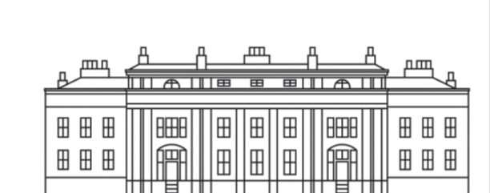

Acknowledging the most incredible collection of 2016 awards and celebrating the International Status of
‘Europe’s Best Destination Wedding Retreat’

BALBIRNIE HOUSE
2017
THE YEAR OF ‘HYGGE’
Hygge (pronounced hue-gah) is a Danish word that is a feeling or mood that comes from taking genuine pleasure in making ordinary, everyday moments more meaningful, beautiful or special.
Hygge is being aware of a good moment whether it’s simple or special.
While there’s no single word to describe hygge, several can be used interchangeably to describe the idea of hygge such as cosiness, charm, happiness, contentness, security,
Familiarity, comfort, reassurance, kinship, and simpleness.

Please join us on Facebook, Instagram, or any of our 7 Twitter feeds! @balbirniehouse
#hygge

BALBIRNIE HOUSE
AFTERNOON TEA

TRADITIONAL
£14.95

a selection of freshly prepared finger sandwiches, mini quiche and
savoury sausage rolls
warm scones served with clotted cream and preserves
Chefs’ own selection of dainty cakes and pastries

OR

‘HYGGE’
£14.95

INTRODUCING BALBIRNIE’S INTERPRETATION OF DANISH SMØRREBRØD
(PRONOUNCED SMUHR-BROHT)

the above selection of cakes and pastries with open-faced sandwiches served on ‘rugbrød’ rye bread

CHAMPAGNE
£18.95
Inclusive of a 125ml glass of our house Champagne ‘Chimere’

All served with your choice of Nespresso coffee, Scottish tea or hot chocolate
Brodies flavoured teas are also available on request

UPGRADE TO BALBIRNIE’S OWN RECIPE
MULLED WINE OR MULLED CIDER FOR £4.50

PLEASE INFORM US IF A PERSON IN YOUR PARTY HAS A FOOD ALLERGY
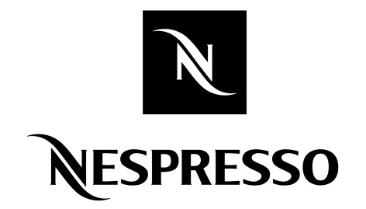
Our products may contain wheat, egg, dairy, soy, fish or other allergens.

All prices are per person and inclusive of VAT
Gratuities at your discretion

