**LOUNGE AREAS, GARDENS AND COURTYARD**

Available from 12pm - 9pm

**SMALL PLATES £4.50**

**SEA BASS**

summer greens, salsa verde

**SMOKED SALMON**

rye, lemon and herb mayonnaise

**KING PRAWNS**

garlic, chilli,lime

**BRAISED BEEF**

couscous, njudja

**PROSCIUTTO**

sourdough, rapeseed

**ASPARAGUS**

lemon, hollandaise

**SLIDERS £4.50**

**HOT SMOKED SALMON**

caper aioli

**SEA BASS**

rocket, garlic and herb mayonnaise

**SATAY CHICKEN**

carrot, cucumber and sweet chilli

**PULLED BEEF**

trafata, creme fraiche

**SPICY SAUSAGE**

prosciutto, basil

**CRISPY LAMB**

harissa, tzatziki

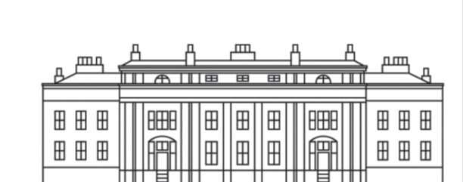 *Available from 10am- 5.30pm*

**SANDWICH SELECTION**

**MINUTE STEAK £8.95**

toasted Boccadillo, rocket, caramelised red onion chutney

**BALBIRNIE TOASTED CLUB SANDWICH £7.95**

grilled chicken, bacon, lettuce and tomato, fried egg

**GRILLED FOCACCIA £6.95**

plum tomato, mozzarella, rocket and basil pesto

***SOUP OF THE DAY £4.50***

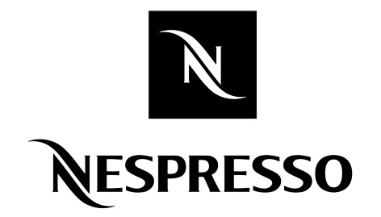

BEFORE PLACING YOUR ORDER,

PLEASE INFORM US IF A PERSON IN YOUR PARTY HAS A FOOD ALLERGY

Our products may contain wheat, egg, dairy, soy, fish or other allergens.

All prices are inclusive of VAT

Gratuities at your discretion

**CLASSICS £5.95**

Served with salad garnish and crisps *on your choice of malted brown*

*or softgrain white bread*

**OAK SMOKED SALMON**

cream cheese and cucumber

**HONEY ROAST HAM**

grain mustard mayonnaise

**SCOTTISH ROAST BEEF**

horseradish and rocket

**MATURE CHEDDAR CHEESE**

branston pickle

**FREE RANGE EGG**

mayonnaise and cress

£2.00

£3.25

£3.25

£3.25

£3.25

£3.25

£3.25

£3.25

**Espresso**

**Double Espresso**

**Americano**

**Café Lungo**

**Cappuccino**

**Café Latte**

**Iced Latte**

**Decaffeinated**

**BRODIES TEAS**

### All priced at £3.25

### Scottish Breakfast or Afternoon

**Decaffeinated**

## Earl Grey

## Darjeeling

**Peppermint**

**Camomile**

**Citrus and Lemongrass**

**Forest Fruits**

**Apple and Mango**

*Why not?*

Add your favourite whisky or liqueur to your coffee.