Scotland’s Cezanne, at Balbirnie House.

The 12 piece collection of artwork which is now in place in and around Balbirnie’s Orangery, has been gifted to us by Archie Forrest,
who is Scotland’s leading contemporary Colourist painter.

The collection especially commemorates daughter Maya’s wedding,
which took place at Balbirnie House early in 2014.

Biog. 'Whether in landscape, still life or figure painting, Forrest has the ability to use the language of paint to devastating effect; as one admirer remarked, ''he creates electricity with paint.”

Archie Forrest paintings have been shown at The Scottish Gallery in late 2014,and are currently available from London’s Portland Gallery.

PLEASE INFORM US IF A PERSON IN YOUR PARTY HAS A FOOD ALLERGY
Our products may contain wheat, egg, dairy, soy, fish or other allergens.

All prices are per person and inclusive of VAT
Gratuities at your discretion

BALBIRNIE HOUSE
AFTERNOON TEA

A SELECTION OF FRESHLY PREPARED FINGER SANDWICHES
smoked salmon and crème fraiche
cucumber and cream cheese
free range egg mayonnaise and cress
ham and wholegrain mustard mayonnaise

-oOo-

mini cheese and onion quiche
pork and apple sausage roll

-oOo-

SELECTION OF WARM SULTANA AND PLAIN SCONES
served with clotted cream and strawberry preserve

-oOo-

CHEFS’ OWN SELECTION OF DAINTY CAKES

TRADITIONAL £14.95

OR

CHANDON £18.95

Inclusive of a 125ml glass of Chandon Brut, Mendoza, Argentina

A fresh and elegant style with citrus and pineapple aromas which follow
through to a fresh, crisp palate and delicious soft mousse. (13% abv)
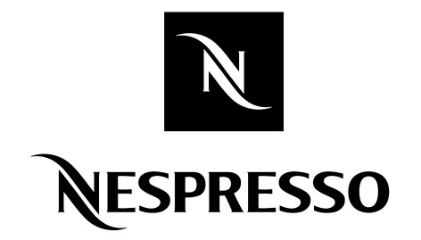
-oOo-

All served with your choice of Nespresso coffee,
Scottish tea or hot chocolate
‘Brodies flavoured teas are also available on request’

