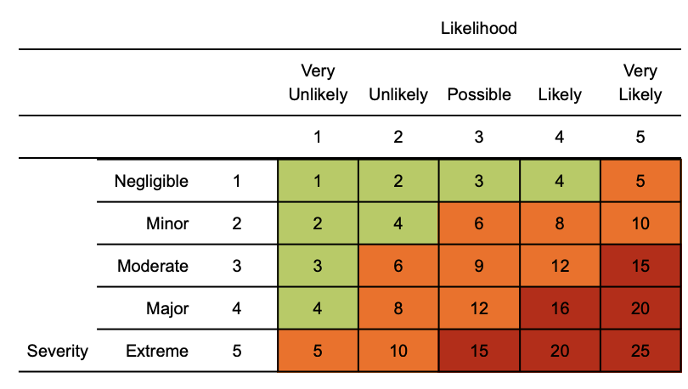
Risk matrix used in risk assessment below
RR = residual risk

Use guidance from World Health Organization and NHS to ensure the risk assessment is following the latest advice.

Coronavirus (COVID-19) risk assessment

Assessment date: 13th Aug 2020
Review date: 13th Aug 2021
Version: 2.0

Hazard | Risk | Control measures | RR | Persons at risk
Exposure from COVID-19 due to:  Living with someone with a confirmed case of COVID-19.  Coming into close contact (within 2 metres for 15 minutes or more) with a confirmed case of COVID-19.  Being advised by a public health agency that contact with a diagnosed case has occurred in local area. | 4  x  3  =  12 | - Follow government advice on self isolation and Test & Protect. Workers should work from home where possible.  - Any existing individual risk assessments (disability, young persons or new / expectant mothers) to be reviewed.  - Maintain contact with line management Health and Safety and People Services Departments and to follow College policy / guidance.  - Business travel and external meetings only undertaken for essential reasons; reduce the amount of time using public transport and to implement social distancing where possible (2m clearance from persons and not to travel in groups of more than 2 unless it is immediate family)  - To continue following ongoing government guidance  - Stay at home if displaying any symptoms and arrange for a test through the Test and Protect program.  - College to ensure vulnerable staff are shielding themselves and following their specific medical advice issued to them.  - Follow good hygiene practices to be followed at all times | 4  x  1  =  4 | Staff, Students, Visitors
Suspected case whilst attending College | 4  x  4  =  16 | If staff or students develop a high temperature or a persistent cough while at work, they should:  - Inform lecturer or line manager immediately.  - The COVID notification form on COLin should be completed and Health and Safety Department Informed.  - Areas where suspect case have been will be identified as much as possible and be quarantined and deep cleaned.  - Individual to return home immediately  - Avoid touching anything as much as possible.  - They must then follow the guidance on self-isolation and arrange a test through Test and Protect. Do not return to work/studies until their period of self-isolation has been completed. | 4  x  1  =  4 | Staff, students & visitors
Lift usage | 4  x  4  =  16 | Lift use should be reduced to maximum of 4 only,  Priority will be given to individuals with obvious mobility challenges. | 4  x  1  =  4 | Staff, students & visitors
Access / egress to site | 4  x  4  =  16 | Where possible, please consider and implement the following practices:  - Controlling access to all non-essential visitors  - Introduce staggered start and finish times of staff and classes to reduce congestion and contact at all times.  - Security personnel to monitor access points to enable social distancing – consideration may need to change the number of access points, either increase to reduce congestion or decrease to enable monitoring.  - Require all workers to wash or clean their hands before entering or leaving campuses.  - Enforce as far as possible social distancing space (two metres) between individuals.  - Regularly clean common contact surfaces in reception, office, access control and delivery areas e.g. scanners, , screens, telephone handsets, desks, particularly during peak flow times  - Reduce the number of people in attendance at site inductions and consider holding them outdoors wherever possible.  - Drivers should remain in their vehicles if the load will allow it and must wash or clean their hands before unloading goods and materials. | 4  x  1  =  4 | Staff, students & visitors
Students being transported to College by bus | 4  x  4  =  16 | - Social distancing should be in operation.  - Face coverings should be worn when in all public areas.  - Numbers being transported at any given time will be reduced. | 4  x  1  =  4 | Students, bus driver.
Poor hygiene | 4  x  4  =  16 | - Wash your hands thoroughly and regularly. Use soap and water for at least 20 seconds.  - Use alcohol-based hand sanitiser if soap and water is not available and hand washing technique to be adopted as directed by NHS.  - Avoid touching your face/eyes/nose/mouth with unwashed hands and cover your cough or sneeze with a tissue then throw it in the bin.  - Regularly clean the hand washing facilities and check soap and sanitiser levels every 2 hours.  - Provide suitable and sufficient recycle bins for hand towels with regular removal and disposal.  - Campuses will need extra supplies of soap, hand sanitiser and paper towels and these should be securely stored.  - Restrict the number of people using toilet facilities at any one time. Wash hands before and after using the facilities  - Enhance the cleaning regimes for toilet facilities particularly door handles, locks and the toilet flush Portable toilets should be avoided wherever possible, but where in use these should be cleaned and emptied more frequently | 4  x  1  =  4 | Staff, students & visitors
Refectories - exposure from large numbers of persons | 4  x  4  =  16 | - Consideration given that break times should be staggered to reduce congestion and contact at all times  - Hand cleaning facilities or hand sanitiser is available at the entrance of any room where people eat and should be used by workers when entering and leaving the area  - Individuals should sit 2 metres apart from each other whilst eating and avoid al physical contact.  - Where catering is provided, it should provide pre-prepared and wrapped food only - Payments should be taken by contactless card wherever possible and Crockery, eating utensils, cups etc. should not be used  - Tables should be cleaned between each use .  - All rubbish should be put straight in the bin and not left for someone else to clear up.  - All areas used for eating must be thoroughly cleaned including chairs, door handles, vending machines and payment devices. | 4  x  1  =  4 | Staff, students & visitors
Use of Changing facilities, showers. | 4  x  4  =  16 | - Introduce enhanced cleaning of all facilities throughout the day and at the end of each day  - Based on the size of each facility, determine how many people can use it at any one time to maintain a distance of two metres | 4  x  1  =  4 | Staff, students & visitors
Car use/ sharing | 4  x  4  =  16 | - Car sharing should be discouraged.  - Hand sanitiseris available in pool cars | 4  x  1  =  4 | Staff.
Working/Studying closely with other individuals | 4  x  4  =  16 | - Always consider if the task can be performed differently without having to breach the 2m social distancing rule.  - Limit face to face working and work facing away from each other when possible  - Limit the frequency of working within 2m to an absolute minimum and ensure it is for strictly low intensity, sporadic work where exposure to this distance is less than 15 mins  - All equipment to be thoroughly cleaned prior and after using it.  - Increased ventilation will be provided within enclosed spaces, windows, doors opened.  - Reusable PPE should be thoroughly cleaned after use and not shared between individuals. These should be stored in suitable places.  - Single use PPE should be disposed of so that it cannot be reused and to control potential contamination is controlled.  - Internal meetings between staff should be virtual where possible. Physical meetings between staff should be avoided where possible. | 4  x  2  =  8 | Staff, students & visitors

Management
- Please ensure all staff are aware of reporting requirements and that all confirmed cases are escalated to the Health and Safety Department.

- A colleague who has been isolated for 14 days cannot return to work until the appropriate ‘fit note’ documentation is provided by their GP/healthcare provider to demonstrate they are now fit to return to work.

- Assessments to be reviewed regularly or where significant change has occurred.

- Please remind staff that in order to minimise the risk of spread of infection, we rely on everyone taking responsibility for their actions and behaviours.

- Open and collaborative approach required between all teams so any issues can be openly discussed and addressed.

