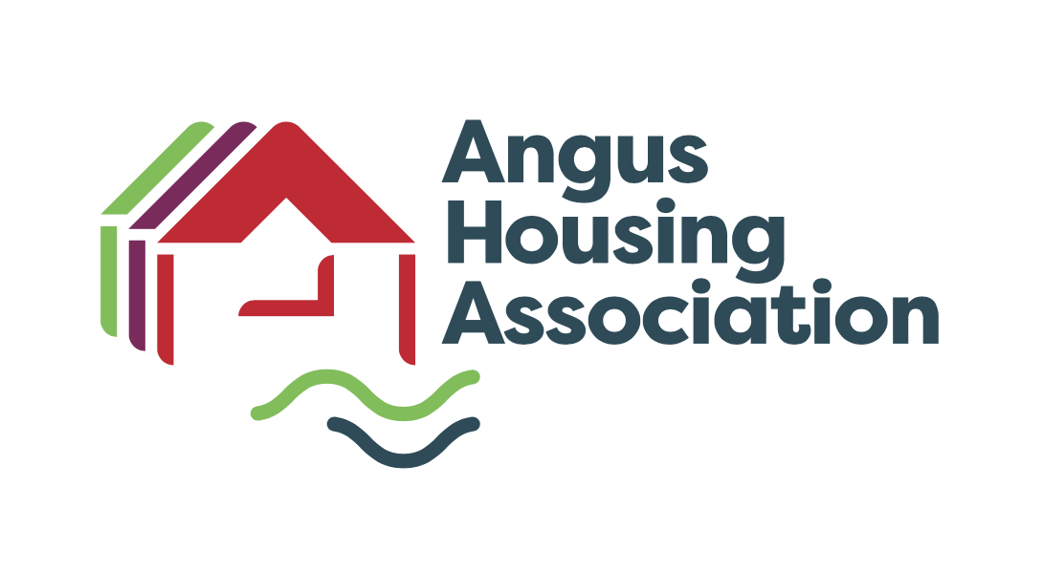

Policy Name |  | Transfer & Management Transfer Policy
Policy Ref
Review Date |  | May 2026
Purpose |  | REVIEW & APPROVE
May |  | May 2030
Committee |  | Service Delivery Policy
Author |  | Linlay Anderson
Internal Policy |  | To be published

Scottish Social Housing Charter  Outcomes | Number(s)
The Customer/landlord relationship | 1.Equalities  2.Communication  3.Participation  4.Quality of Housing  5.Repairs, Maintenance and Improvements  6. Estate Management, Anti-Social Behaviour, Neighbour Nuisance and Tenancy Disputes  7,8 & 9 Housing Options  11. Tenancy Sustainment

Written By | Linlay Anderson
Department | Housing Management

Approval Date by Board | 27th May 2026

Notes
We will comply with all relevant legislation and associated regulations, including:

The Housing (Scotland) Act 1987, 2001 & 2010
The Homelessness etc (Scotland) Act 2003
Data Protection Act (1998)
Sex Discrimination Act 1975 (As Amended)
Race Relations Act 1976 (As Amended)
Disability Discrimination Act 1995
Matrimonial Homes (Family Protection) (Scotland) Act 1981
Protection from Harassment Act 1997
Civil Partnership Act 2004

Reference made to the following sources and other guidance:

SFHA Raising Standards in Housing – Allocations (Revised)
Scottish Housing Regulator Self Assessment in Inspection Criteria
Scottish Executive Good Practice in Housing Management, Chapter Four – Housing Allocation

ANGUS HOUSING ASSOCIATION LIMITED

TRANSFER & MANAGEMEMENT TRANSFER POLICY

1. Management Transfers

The purpose of this policy is to outline the way in which Angus Housing Association proposes to manage Transfer requests within our housing stock and Management Transfers.
Most Registered Social Landlords (RSLs) and Local Authorities have policies to meet the needs of tenants wishing to move within their stock. We have devised a policy which is fair, meets all current statutory obligation and offers tenants who wish to transfer properties a user-friendly system to meet their housing needs and aspirations.

2. What is a Transfer and Management Transfer
Standard Transfers remain tenant-led and assessed through These Homes Choice Based Lettings (CBL) system and the allocations framework
Management Transfers remain an exceptional, urgent rehousing option requiring Senior Management Team Authorisation.

3. Applying for a Transfer
The Association would like our existing tenants to remain with us as long as possible but understand tenants may need to move for a variety of reasons such as underoccupancy, overcrowding, medical requirements. Existing tenants can apply to the Association to move to another property within our stock, through These Homes the Association’s CBL system.
Most tenants are eligible to apply for a transfer, however there are certain restrictions which will apply. We will accept applications from tenants who are assessed as being adequately housed as they may have personal, social or aspirational reasons to move. Normally, tenants assessed as having no immediate need will be considered for a transferred only once other applicants with housing need have had their needs met. Applications will be assessed in accordance with our Allocation Policy.
Applicants wishing to move must complete an online Application Form, through These Homes. Applications will be assessed in line with the Association’s CBL Allocation Policy and following assessment the applicants will be awarded bandings based on housing need. Application will be placed in one of the following bandings:
The Bandings are as follows –
    - Gold Banding
    - Silver Banding
    - Bronze Banding
    - No Priority Banding

The Association strives to meet everyone’s needs and aspirations, however the Association cannot transfer everyone who applies because there is not always suitable vacancies. Whilst we try our best to meet out tenant’s needs on some occasions this might not be possible even though the tenant may meet all the conditions, a suitable vacancy may not arise within the Association stock.
Properties will be allocated as per the Association’s Policy, however the Association has agreed to allow up to 20 properties in any one year to transfers applicants this may result in the Association bypassing some applicants on the waiting list. Any bypasses must be authorised by the Housing Manager or Director of Housing Services.

3.1 Suspensions
We may suspend a tenant’s application in the following circumstances:
- If they are currently subject to legal action by us for housing debt or anti-social behaviour.
- If the tenants property fails to meet a reasonable standard of repair. Prior to an offer being made transfers are subject to a home visit and house inspection to check the property for damage, unauthorised alteration or poor decoration. Should the property fail to meet an appropriate standard the tenant will be advised of the reason/s for the property failing and their application will be suspended pending completion of the necessary works and reviewed thereafter.
Further information please refer to the Association’s Suspensions Policy.

3.2 Appeals Process
If a tenant is unhappy about with any aspect of their application for rehousing, they should refer to the Association’s CBL Application Policy on details of how to appeal.
If the tenant is still dissatisfied they will be able to use our Complaints Policy to take their concerns forward. A copy of this policy is available online or from our Customer Service Team.

4. Management Transfer

A Management Transfer is used to assist in urgent re-housing cases where the Association’s CBL Allocation policy would not deliver a resolution quickly enough. Management Transfers apply to tenants of the Association.

Management transfers will only be granted in exceptional circumstances. The following criteria will be used when considering whether to award a Management Transfer:

- Personal safety of tenant/household member (the tenant or someone in their household is the victim)
- Racial Harassment
- Domestic Abuse
- Other harassment
- Child protection

- The tenant cannot reasonably be expected to continue to occupy current house (where due to tragic personal circumstances or prevention of homelessness)
- Homeless prevention
- Personal circumstances

- Community Safety Issue (the tenant is the perpetrator, but the decision is to offer alternative housing)
  - Multi Agency Public Protection Arrangements (MAPPA)
  - Antisocial closure order

- Best Use of stock (strategic issues)
- Last redevelopment tenant in block
- A request from Social Work to remove an individual or family for personal safety reasons e.g. under Multi Agency Risk Assessment Conference (MARAC)
- The home is adapted for the original tenant and the successor does not have a medical need for those adaptations
- Other reasons as deemed necessary by the Director of Housing Services

Only one reasonable offer of a Management Transfer will be given. The offer of alternative accommodation will be to a property that meets the tenant’s housing needs at the time of rehousing.

However, should the tenant already have an application for housing lodged which has been awarded points for an identified need, then these will be taken into consideration when making an offer of suitable housing. Examples of this can be the need for larger or smaller accommodation or a medical priority for alternative housing.

The Association will carry out a daily check of voids to identify a suitable property. Once a suitable property has been identified, this will be discussed with the Housing Manager and Director of Housing Services.

If a suitable property is identified, approval of the offer of housing on management grounds will be authorised by the Director of Housing Services or a member of Senior Management Team before it is made.

4.1 One reasonable offer

If the offer is refused by the tenant then the Management Transfer priority will be removed. The application will return to the appropriate group for consideration.

However, the tenant will have the right to appeal the decision to remove the priority if they can demonstrate that the offer was unreasonable. The appeal must be made within 10 working days to the Association, giving the reason for the appeal and providing any supporting evidence. This will be reviewed by the Housing Manager or Director of Housing Services.

4.2 Timescale for Review
The Association will review the cases if an offer of housing has not been made within 8 weeks. This may result in the Association approaching the Local Authority or local Housing Associations for assistance.

4.3 Clear Audit Trail

The Housing Management Department will keep a clear audit trail of every Management Transfer awarded, allocation made, refusal with reasons and appeals for future reference.

5. Performance Monitoring and Reporting

The Housing Management Department will monitor and report the number of Transfers and Management Transfers to the Service Delivery Sub Committee along with other allocation performance information. The information will include:

- Number of Transfer Applicants housed in the quarter
- Number of Management Transfers housed in the quarter and reasons for the Management Transfer

6. Equality and diversity
In developing and implementing policies covering all aspects of our work, Angus Housing Association will ensure that our strong principles and commitment to equality of opportunity are evident. In line with the Housing (Scotland) Act 2001 the Association operates in a manner which encourages equal opportunities and observes the equal opportunity requirements described in Section 106 of the Act. The Association also takes account of all applicable legislation, including the Equality Act 2010 and relevant Codes of Practice issued by the Equality and Human Rights Commission -
Our Policy recognises the protected characteristics as defined by the Equalities Act:
- Age  - Disability  - Gender reassignment  - Marriage and civil partnership  - Pregnancy and maternity | - Race  - Religion or belief  - Gender  - Sexual orientation

In line with this commitment to equal opportunities, this policy and any summary or information leaflet can be made available free of charge in a variety of formats including large print, translated into another language or on audio tape.
7. Monitor and Review

This policy will be reviewed on a four yearly basis and more frequently should be
required. The review will assess the effectiveness of the policy and accompanying
procedure and identify any changes which may be required.

As part of this policy review, consultation will take place with both staff and tenants to
ensure accounting is taken of operational issues and the opinions of service users.

