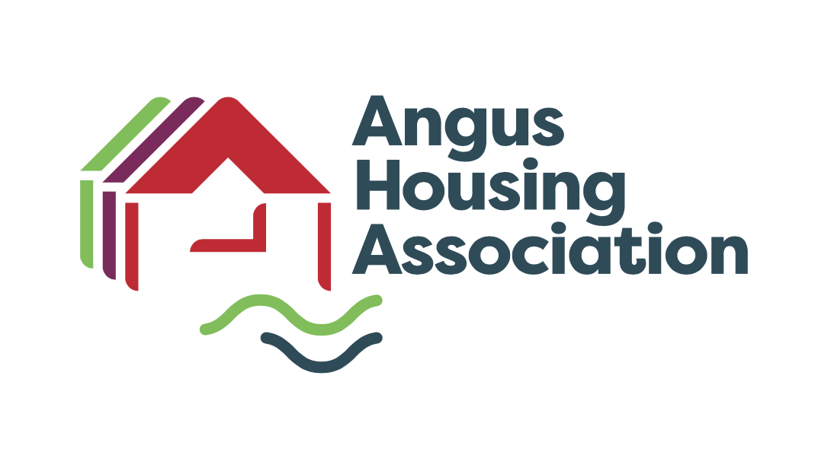

Policy Name |  | Decant Policy
Policy Ref
Review Date |  | August 2026
Purpose |  | REVIEW & APPROVE
Next Review Date |  | August 2030
Committee |  | Service Delivery Sub Committee
Author |  | Linlay Anderson
Internal Policy |  | To be published

Angus Housing Association Limited Registered Charity Number SC020981

Scottish Social Housing Charter | Outcomes
This policy has been developed with reference to the Scottish Social Housing Charter (November 2022). | 1 Equalities, 2 Communication, 3 Participation, 4 Quality of Housing, 5 Repairs, Maintenance and Improvements, 7-9 Housing Options, 10 Access to Social Housing, 11 Tenancy Sustainment and 13 Value for Money
Written By | Linlay Anderson
Department | Housing Management

Approval Date by Committee | 2 September 2026

Notes

First Approved by Committee 31 October 2012
Reviewed September 2017
Reviewed August 2022
Reviewed August 2026

ANGUS HOUSING ASSOCIATION LIMITED
DECANT POLICY

1. Introduction

1.1 This policy sets out how Angus Housing Association will manage temporary and permanent decants where a tenant or household needs to move from their home because major repairs, improvement works, remodeling, redevelopment, demolition or an emergency situation makes it unsafe or unreasonable for them to remain in occupation.

The Association will only use decanting where this is necessary. In every case we will consider whether work can be completed safely while the tenant remains in their home. Where decanting is required, we will seek to minimise disruption, provide clear information, take account of individual needs and keep tenants at the center of decisions affecting them.

1.2 The period of decant should be kept to the shortest reasonable time, with regular communication provided throughout.

1.3 Where applicable a payment will be made to them under the following categories:
- Home Loss Payments
- Decant Payments
- Replacement Allowances

1.4 The Association will explain clearly which payments are statutory, discretionary or reimbursement based. Any proposal to offset a discretionary payment against a debt owed to the Association will be considered carefully and discussed with the tenant.

1.5 As far as reasonably possible the Association will ensure existing residents can return or remain in the locality. However, this may not always be possible particularly when a scheme is being remodelled with fewer properties than originally. If this is the case, we will work with residents to provide options for rehousing.

2. Definitions

2.1 Decanting: The process of temporarily or permanently moving a
tenant or household from their home where works, redevelopment, demolition or an emergency situation make occupation unsafe or unreasonable.

2.2 A Permanent Decant: A move where the household will not return to the
original home.

2.3 A Temporary Decant: This is when a resident is moved out of their property,
to enable work on the property to be carried out, with the intention of returning them to the property at the earliest opportunity.

2.4 Alternative accommodation: Accommodation that is safe, of an appropriate
standard and as suitable as reasonably possible for the household’s size, medical and support needs, accessibility requirements, caring responsibilities, schooling, work and locality.

2.4 The Association does not consider it appropriate to use the decanting process to move Tenants permanently who may wish to transfer for reasons other those identified as the reasons for decanting.

3. Aims and Objectives

3.1 Aims
The aims of this policy are:
- To manage decants fairly, lawfully, consistently and compassionately
- To keep disruption to tenants and their households to the lowest reasonable level
- To communicate clearly and involve tenants in decisions affecting their move
- To take account of individual needs, equalities duties and accessibility requirements

3.2 Objectives
The objectives of this policy are to ensure that:
- Tenants receive clear information about the reason for the move, likely timescales, support available and any payments due
- Accommodation is suitable, safe and as close as reasonably possible to the tenant’s existing home and support networks
- Practical assistance is provided with moving, reconnections, storage and other reasonable arrangements
- The Association makes reasonable adjustments and takes account of medical, disability, support and vulnerability-related needs
- Payments are made fairly and as promptly as reasonably possible
- The Association learns from decant cases, feedback and complaints to improve future service delivery

4. Relevant Legislation

4.1 Home loss payments in Scotland are governed by the Land Compensation (Scotland) Act 1973 and related legislation. The Association will also have regard to other relevant housing, health and safety, equality and data protection requirements when managing decants.

In addition to the above the claimant’s removal must be because of one of the following events:
- Compulsory acquisition of the property by a body with compulsory purchase powers
- Demolition, improvement or closing order under the Housing (Scotland) Act 1987
- The Development of Land acquired by an authority with compulsory purchase powers
- Demolition of a dangerous building
- A court order for recovery of possession proceedings by an RSL, with suitable alternative accommodation being available to the tenant. This only applies to secure tenants

4.2 A claimant is required to meet all the following criteria to qualify for a home loss payment:
- They must have occupied the property as their sole or main residence for a period of one year prior to the date of displacement
- The move must be permanent
- The claimant must be a tenant, a spouse with occupancy rights under the Matrimonial Homes (Family Protection) (Scotland) Act 1981 or any person with any “interest in the dwelling house” for example Qualifying Occupier

5. Types of Decant

5.1 The type of decant will depend on the circumstances of the case, the expected duration of the move, the availability of suitable accommodation and, importantly, the needs and preferences of the tenant and household. The Association will discuss options with the tenant and seek the most suitable and proportionate arrangement in each case.

5.1.1 Tenant-arranged temporary accommodation
Where a tenant prefers to stay with family or friends, or to make another temporary arrangement, the Association may agree to this where it is suitable and safe. We will explain what support and reimbursement may be available in these circumstances.

5.1.2 Decant to an Angus Housing Association property
Where possible, the Association will use a suitable temporary or permanent property from its own stock. If a temporary move is arranged, we will explain the basis of the move, the rent arrangements and whether and when the tenant is expected to return to their original home.

5.1.3 Assistance from another landlord
If the Association cannot provide suitable accommodation from its own stock, we may work with another landlord or partner organisation to secure appropriate accommodation.

5.1.4 Furnished or serviced temporary accommodation
Furnished or serviced accommodation may be used for short-term decants where this is the most suitable option. Storage costs and other reasonable practical arrangements will normally be met by the Association.

5.1.5 Emergency accommodation
Hotel or bed and breakfast accommodation may be used only as a short-term emergency measure where no more suitable option is immediately available. The Association will seek to move the household to more suitable accommodation as quickly as possible.

5.1.6 Other exceptional arrangements
In exceptional cases, other arrangements may be considered where these are safe, lawful and suitable for the household. Any such arrangement will be assessed carefully with the tenant’s needs and wellbeing in mind.

6. Accommodation Criteria and Support

6.1 The Association will seek to provide accommodation that is safe, suitable and of an appropriate standard for the household. We will complete a proportionate assessment of needs before a move is arranged wherever circumstances allow.

6.2 When assessing suitability, the Association will take account of household size, medical or disability-related needs, accessibility requirements, caring responsibilities, schooling, employment, support networks, risk factors, pets where relevant and the tenant’s preferences.

6.3 Where reasonably possible, tenants moved because of major works or remodelling will be offered accommodation with a similar number of bedrooms or apartments to their existing home. Where this is not possible, the Association will explain the reasons and discuss suitable alternatives with the tenant.

6.4 Decant accommodation will meet the Association’s normal letting standard and will be safe, clean, wind and watertight, with working heating, hot water and suitable floor coverings where appropriate.

6.5 Where a temporary decant is arranged, the Association will explain the expected duration of the move, the basis on which the tenant will return and any arrangements that apply if the works are delayed or change in scope.

6.6 Where a permanent move is required, the Association will work with the tenant to identify suitable rehousing options and will keep them informed of likely timescales and next steps.

6.7 As part of the decant process, the Association will normally arrange and pay for reasonable practical support including removals, storage where required, mail redirection and relevant connection or reconnection costs. Tenants may choose to make some arrangements themselves, in which case reimbursement may be considered in line with this policy and Appendix 1.

6.8 The Association will liaise with relevant services, with the tenant’s consent where appropriate, to help maintain support arrangements such as telecare, emergency alarm services, meals services or other essential support.

6.9 Tenants are responsible for notifying their home contents insurer of any move. The Association will encourage tenants to check that insurance and other household arrangements remain appropriate during the decant period.

7. Home Loss and Decant Payments

7.1 The Association will explain clearly what payments or reimbursements may apply in each case. These may include statutory home loss payments, decant payments, reimbursement of reasonable costs and replacement allowances.

7.2 Where a tenant qualifies for a statutory home loss payment, the Association will pay this in accordance with the relevant legislation. The amount payable will be the current applicable prescribed amount at the relevant time.

7.3 The Association will normally meet or reimburse reasonable decant-related costs where these are agreed in advance or are clearly necessary, for example removals, storage, redirection of mail, reconnections and other agreed arrangements.

7.4 Where evidence is needed to support reimbursement, the Association will explain this clearly and will seek to make payment as promptly as reasonably possible once the required information is received.

7.5 Tenants who are decanted because of fire, flood or a similar insured event will not normally be entitled to a home loss payment or to financial contributions towards decoration, floor coverings or window coverings, as these costs should ordinarily be met through the tenant’s home contents insurance. However, where the fire, flood or similar incident was caused by an act or omission of the Association, any payment or contribution will be considered on the individual circumstances of the case.

8. Replacement Allowances

8.1 Replacement allowances are intended to ensure that tenants are not left significantly out of pocket as a direct result of works or decant arrangements. These are contributory payments and are not intended to provide full replacement in every case.

8.2 The types of replacement allowance and the amounts payable are set out in Appendix 1. The Association will explain the criteria for any payment and any evidence that may be needed before payment is made.

8.3 Allowances may be considered where, for example, decoration, blinds, curtains or floor coverings are directly affected by works and cannot reasonably be reused, repaired or refitted.

8.4 Where the Association arranges removal and storage of furniture, it will ensure that suitable contractual and insurance arrangements are in place with any appointed contractor.

9. Emergency Situations

9.1 Where an emergency such as fire, flood, major damage or another serious incident makes a home immediately unsafe or uninhabitable, the Association will prioritise the safety and immediate wellbeing of the tenant and household.

9.2 In the first instance, the Association will seek to secure safe temporary accommodation for the household and, where relevant, take account of the needs of children, support needs, medication, pets and any essential equipment.

9.3 Once the immediate emergency has been stabilised, the Association will assess whether the tenant can return home quickly or whether a temporary or permanent decant is required. From that point, the normal decant process and support arrangements under this policy will apply as far as reasonably possible.

9.4 Emergency cases will be managed sensitively and flexibly, recognising that households may be distressed and may need additional practical support, reassurance and communication.

10. Confidentiality

10.1 Under the UK General Data Protection Regulation, the Data Protection Act 2018 and the Human Rights Act 1998, all personal and sensitive organisational information, however received, is treated as confidential. Information will only be shared where this is lawful, proportionate and necessary.
- anything of a personal nature that is not a matter of public record about a resident, client, applicant, staff or committee member
- sensitive organisational information Officers will ensure that they only involve other agencies and share information with the consent of the resident concerned, unless:
- The Association is required to by law
- The information is necessary for the protection of children

11. Equality, Diversity and Accessibility

11.1 In developing and implementing policies covering all aspects of our work, Angus Housing Association will ensure that our strong principles and commitment to equality of opportunity are evident. In line with the Housing (Scotland) Act 2001 the Association operates in a manner which encourages equal opportunities and observes the equal opportunity requirements described in Section 106 of the Act. The Association also takes account of all applicable legislation, including the Equality Act 2010 and relevant Codes of Practice issued by the Equality and Human Rights Commission -
Our Policy recognises the protected characteristics as defined by the Equalities Act:
- Age  - Disability  - Gender reassignment  - Marriage and civil partnership  - Pregnancy and maternity | - Race  - Religion or belief  - Gender  - Sexual orientation

In line with this commitment to equal opportunities, this policy and any summary or information leaflet can be made available free of charge in a variety of formats including large print, translated into another language or on audio tape.

12. Monitoring and evaluation

12.1 We will manage and monitor all decants to support service improvement, assurance and value for money. Monitoring may include the number and reason for decants, timescales, outcomes, tenant satisfaction, complaints, equality considerations and lessons learned.

The following indicators will be used:
- Reasons for decant
- Tenant satisfaction

13. Health & Safety

13.1 This policy will be carried out in compliance with all relevant statutory Health and Safety requirements and regulations.

14. Policy Review
The Association will review the Decant Policy every 4 years with the next review taking place in August 2030, or earlier if required following a substantive legislative, regulatory or good practice change.


APPENDIX 1

1. Home Loss Payments £1,500

2. Full removal service, inc. removal and This will be undertaken by the
storage of furniture, all household items, Landlord and will be provided
redirection of mail, telephone, utilities, for all decants (permanent or
redirection of mail, telephone, utilities, temporary)
Carpets, floor coverings

Tenants making their own arrangements £500
for removals

3. Replacement Allowances

Blinds/Curtains (per blind or curtain set) £100 Single window
£200 Double window

Floor Covering Allowance
Damage to Existing (per carpet) £150

Damage to Wooden,
Laminate £150

Decant Payments Explained

Replacement allowances and decant payments are intended to ensure that tenants are not left significantly out of pocket because of a decant or major works. This factsheet explains the main payments that may apply, the level of contribution available and what evidence may be needed.

Payment | How much will I receive | How will I receive my payment
Decoration | All rooms affected by repair works will be fully decorated prior to the return of the current/new tenant. This will be a basic paint finish and no payment will be made.
Window Blinds | Where new windows have been installed and existing blinds no longer fit, the Association pay towards replacement or alteration. Evidence may be requested to confirm that the existing blinds can no longer be used. | Approved payments will normally be made by bank transfer. Where this is not possible, the Association will discuss an appropriate alternative payment method with the tenant.
Floor Covering Allowance | Where existing floor coverings can no longer reasonably be reused because of the works, a contribution per covering may be paid, where the relevant criteria are met. | Approved payments will normally be made by bank transfer. Where the tenant chooses to use the Association’s approved supplier, Angus Housing Association may pay its contribution directly to the supplier, with the tenant meeting any balance due.
Additional electric/gas charges | If a temporary move results in additional energy costs, the Association may consider reimbursement where the tenant provides reasonable evidence, such as recent bills, statements or a supplier letter. Any reimbursement will relate to additional costs reasonably incurred as a direct result of the decant. | Approved payments will normally be made by bank transfer. Where this is not possible, the Association will discuss an appropriate alternative payment method with the tenant.
TV/Broadband/Phone Charges | If a tenant incurs additional TV, broadband or phone charges directly because of the move to decant accommodation, the Association may consider reimbursement where documentary evidence is provided, such as a bill, statement or supplier confirmation. | Approved payments will normally be made by bank transfer. Where this is not possible, the Association will discuss an appropriate alternative payment method with the tenant.
Mail Redirection | The Association may reimburse the reasonable cost of mail redirection where a receipt or other evidence is provided.. | Approved payments will normally be made by bank transfer. Where this is not possible, the Association will discuss an appropriate alternative payment method with the tenant.

Please note that cash payments will not normally be made for the items listed above.
Where all required information has been received, the Association will aim to make payment as promptly as reasonably possible.

