A CELEBRATION OF LIFE - @BalbirnieHouse
As the 2017 Haute Grandeur ‘Best Function Venue Hotel for Europe’, we are doing all we can first and foremost, to ensure Balbirnie House remains at the forefront of providing amazingly great value for our local communities, across the span of Fife’s 350,000 residents.
Over many years, Balbirnie House has been the backdrop as a reception venue following many local funerals. Over recent years however, we have seen an accelerating shift whereby some families align towards turning many such occasions into …
A Celebration of Life.
Allow us to more fully explain.
From our Facebook page, November 2017
'A CELEBRATION OF LIFE'
This morning, our Special Events Department has received such a wonderful, heartfelt and happy letter, from a client who recently arranged their mother's Celebration of Life, at Balbirnie House.
We are seeing more and more of these occasions taking place at Balbirnie House, and we certainly never cease to be amazed at the individuality, creativity and joy we see.
Many people don't know what A Celebration of Life actually is, so this Facebook post is simply to highlight a few related articles.
All best wishes, Special Events
Life celebrations are such a sensitive matter for all families, but one certainly worth highlighting. Our Special Events can also extend into considering special accommodation pricing, for everyone who attends any such occasions from afar.
Our Special Event Planning Department is at your disposal as always. These days we have a team of 5 working on event planning, and if asked to do so, we're always delighted to make suggestions for any and all occasions.
Talking of individuality and creativity: '100+ Best Celebration of Life Ideas!' https://www.loveliveson.com/100-best-celebration-of-life-ideas-2
The heart image which we have used for this post, was selected by the team taking part in this morning's 10.30am team briefing. Original article: CREATIVE WAYS TO INCORPORATE PHOTOS INTO A CELEBRATION OF LIFE SERVICE https://www.homesteaderslife.com/blog/creative-ways-to-incorporate-photos-into-a-celebration-of-life-service
Celebration of Individuality: http://www.bbc.co.uk/news/magazine-31940529

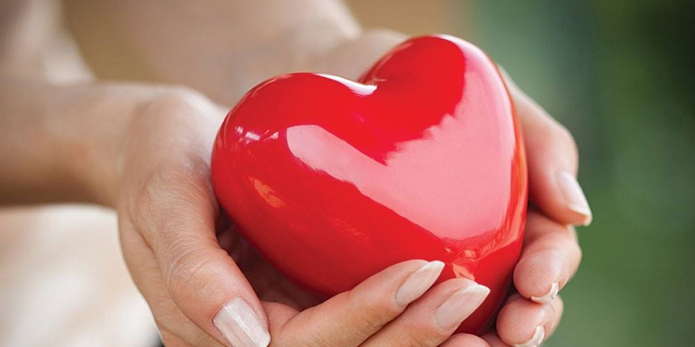

Please liaise with our Special Events Team, with regards to timing for access for pre-preparations on the day of The Celebration of Life itself. We can display photographs, mementos, any and all such aspects, in advance of any funeral service, so as to be awaiting the arrival of guests. We have Bluetooth sound systems for music of your choice, played via your own device. We also have Bluetooth portable wall projectors, which you can use to show images or footage of your choice. We always advise clients to test run any technological equipment in advance of departing for a funeral service, on the day itself.

CATERING ARRANGEMENTS
Option 1;
Hire of our Garden Room, West Room, Orangery, or Millennium Ballroom, numbers depending.
Buffet of choice served with tea, coffee and homemade shortbread
@ £13.95 per person
Choose 3 of the options below
Selection of freshly prepared sandwiches with assorted fillings
Pork & pickle sausage rolls, mustard aioli
Thai spiced salmon fishcakes, soy & sesame
Goat’s cheese & red onion tartlets
Spicy vegetable tempura, tomato & chilli jam
Prosciutto, garden pea & mint Arancini balls, cucumber yoghurt
Tomato & mozzarella bruschetta’s, basil pesto, balsamic
Freshly baked scones and home-made cakes, whipped cream & preserves
Mulled cheddar, chutney & Oatcakes

Option 2;
Hire of our Garden Room, West Room, Orangery, or Millennium Ballroom, numbers depending
A glass of Prosecco on arrival
Buffet of choice served with tea, coffee and homemade shortbread
@ £18.95
Choose 3 of the options below
Mini steak & ale / chicken & mushroom pies
Mini smoked salmon & cream cheese bagels, dill pesto
Mini pokes of beer battered fish & chips, malt vinegar salt
Piri Piri Chicken & Red pepper brochettes
Mini pokes of beer battered fish & chips, malt vinegar salt
Buccleuch Haggis Spring rolls, sweet chilli
Chocolate brownie bites, butterscotch cream
Cheese burger sliders
Cottage pie tartlet

Do wish us to serve everyone with a round of Scotch? Schnapps? Champagne? Cosmo cocktails? Bucks Fizz or Bellinis? Just let us know. We can also operate entire bars, with all billing to main account.

Would you wish the services of our in-house piper, for the arrival of guests?
Do you wish to incorporate the services of a pipe band? Wild Celtic bagpipes? A jazz band? Or how about a Mexican Mariachi band, with trumpets as well? String quartets, classic or contemporary? Acoustic guitarists?
Silent fireworks? A professional photographer? A magician, a cartoonist for commemorative images?
Our Planning Team are at your call, please simply advise us, what you wish to provide.

THE FAMILY CATCHUP, THE NIGHT BEFORE, THE NIGHT OF, OR/ AND THE MORNING AFTER?
Do you have family travelling from afar? Not had a family gathering for a long time?
Then why not arrange a get together the night before The Celebration of Life, for a proper catch up. Book one of our private rooms on a complimentary basis and enjoy a
delicious dinner together @ £25 per person
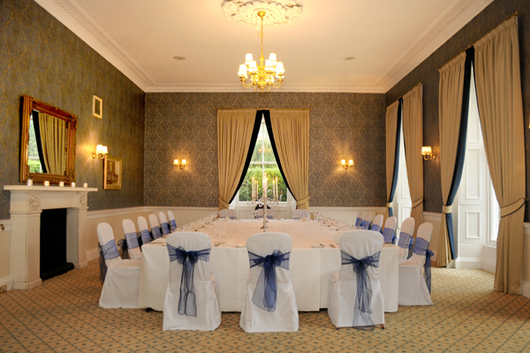

Accommodation rates:
Single @ £95.00 B&B
Standard double @ £145.00 B&B
Deluxe double/twin @ £195.00 B&B
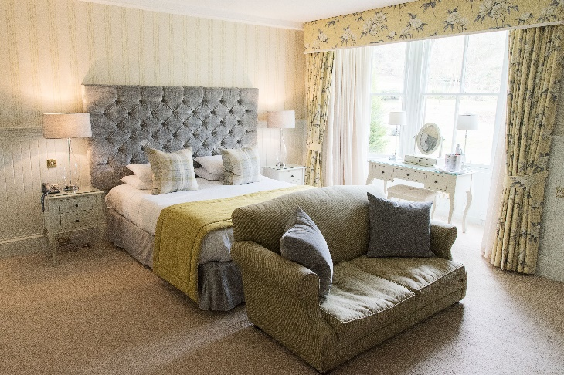
To make a reservation for either a Funeral, or a Celebration of Life, or for further information please contact our Special Events team
Balbirnie House
Markinch
Fife
Scotland KY7 6NE

Tel: 01592 610066
Email: sarah@balbirnie.co.uk

Balbirnie is:

- Haute Grandeur’s Top Wedding Destination Hotel in Europe 2017
- Luxury Travel Guide’s 2016 Luxury Country House of the Year, an award denoted with global perspective.
- 11th time annual winner, Scottish Hotel Awards, ‘Scotland’s Wedding Hotel of the Year’
- Scottish Hotel Awards, ‘Scotland’s 2016 National Hotel of the Year

For all the news, Offers and daily updates on Special Events, please click our ‘Like’ button on Facebook, and ‘Follow’ on Twitter.

www.balbirnie.co.uk

