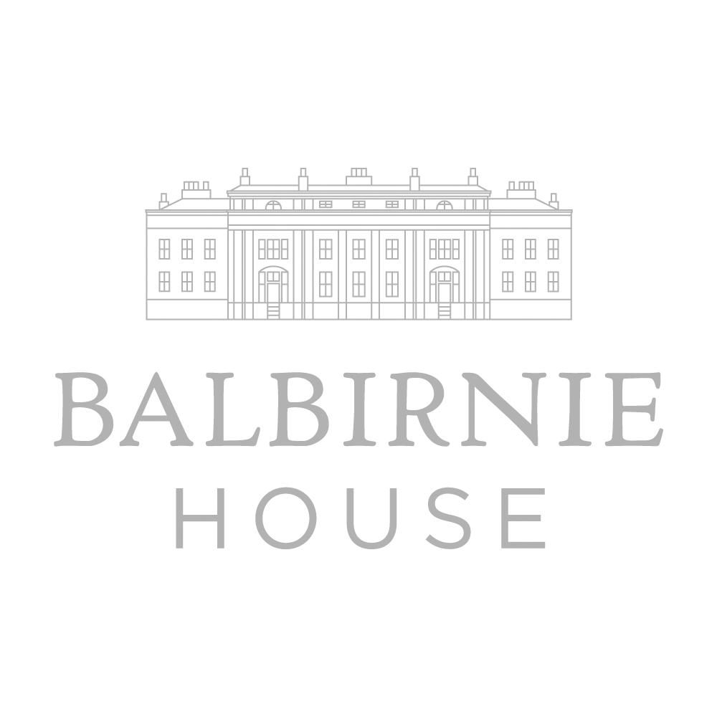
Truly wonderful proposals
For your Birthday Celebrations


Simply outstanding value @ £48.50 per person!
- Welcome glass of Balbirnie House Champagne
- 4 course set dinner menu with, canapés, coffee and tablet
- Complimentary menu cards, table plan and place cards
- Complimentary Tea lights, Cake Stand & Knife
- Complimentary iPod docking station & Chair Covers
- Dedicated Special Events Co-ordinator

PLANNING YOUR BIRTHDAY CELEBRATION AT BALBIRNIE

It's your special event, so celebrate somewhere that holds a special place in your heart. Let us help make your birthday memorable.

With two lovely restaurants and a number of beautiful private rooms to choose from, we can assist with planning your birthday celebration; you can be confident your party will be perfect, right down to the last tiny detail.

With many families wishing to return to Balbirnie over the years, we would be simply delighted to assist with your next special event. We cannot even begin to convey how special it has been over so many years to see these celebratory occasions taking place in the house on a daily basis. So very special. And long may we continue.
In an overall planning context, as always, we say that we start with a blank canvas. We hope that our suggestions are helpful, and if you, as our client, have any special requests or suggestions, then please do let us know. We will always be absolutely delighted to consider incorporating any and all special requests which we consider we can physically deliver, and we certainly do not mind being put to the test!
Over the years we have seen some quite incredible parties here at Balbirnie, and here’s to those wonderful celebrations ahead!

MENU OPTIONS

We are justifiably proud of the enviable reputation we have for dining at Balbirnie. Attached you will find our current Seasonal Orangery Menu and wine list for your consideration. As well as these suggestions, we are always pleased to discuss individual ideas further and develop special menus for your own celebration. The content of your chosen menu will depend on how many guests you have attending your dinner/lunch. With other comparable dining destinations across the country in mind our fixed price inclusive menus offer absolutely wonderful value.

A NOTE REGARDING OUR IN-HOUSE CHEF’S SPECIALITIES!
Worth mentioning, our Balbirnie house specialities ~ our seasonal menus feature hot smoked fish from Balbirnie’s in-house smoker, our House terrine, and of course Balbirnie’s homemade ice creams and sorbets, all made here on the premises. Delicious! Each of our seasonal menu changeovers features new introductions on twitter @BalbirnieHouse

PRIVATE DINING OPTIONS

A little information on our different private rooms - Balbirnie has six quite different private dining areas which can accommodate anything from small private dining parties to larger events for up to 216.

For pre-lunch or dinner drinks, we will always be delighted to set aside an area for you to welcome your guests and enjoy an aperitif.

The Garden Room
A lovely room overlooking the lawns – ideal for smaller occasions. Beautifully decorated with Snowtree by Colefax & Fowler wallpaper, bringing garden elements to the room.

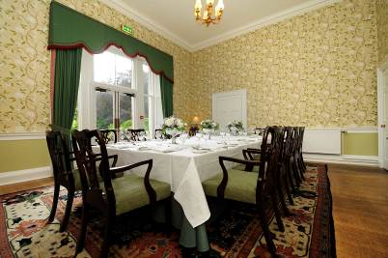

The West Room
Again overlooking our beautiful gardens with custom made curtains from Osborne Heath and truly stunning wallpaper, Aurelia by Harlequin.

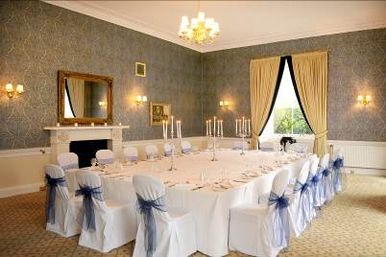

The Orangery
Simply fabulous! This is our main restaurant (voted one of Scotsman’s top 5 most romantic restaurants in the country) which can also be reserved for private events. The Orangery is a wonderful room to host an event, with floor to ceiling lunette windows, a glass roof ceiling and is sumptuously decorated in shades of silver, copper and chocolate. Unique wallpaper, Zoffany, Akita Pleat brings a further glamorous touch. The areas in and around Balbirnie’s Orangery are home to the Archie Forrest collection of 12 artworks gifted to Balbirnie in 2014 by Scotland’s leading contemporary Colourist painter.

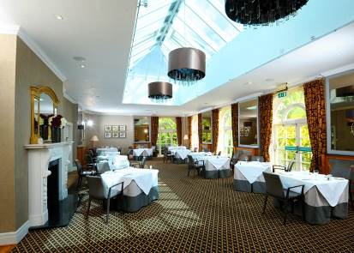

The Bistro
The Bistro is our alternative restaurant at Balbirnie, offering a more casual dining experience with a relaxed and informal ambience in an authentic Bistro style setting, located in the original old kitchens of the house. The Bistro can be booked for private use for over 30 guests – perfect for parties and celebrations! The Balbirnie Bistro offers Proper Bistro Food, with many acknowledgements to classic Bistro cooking.

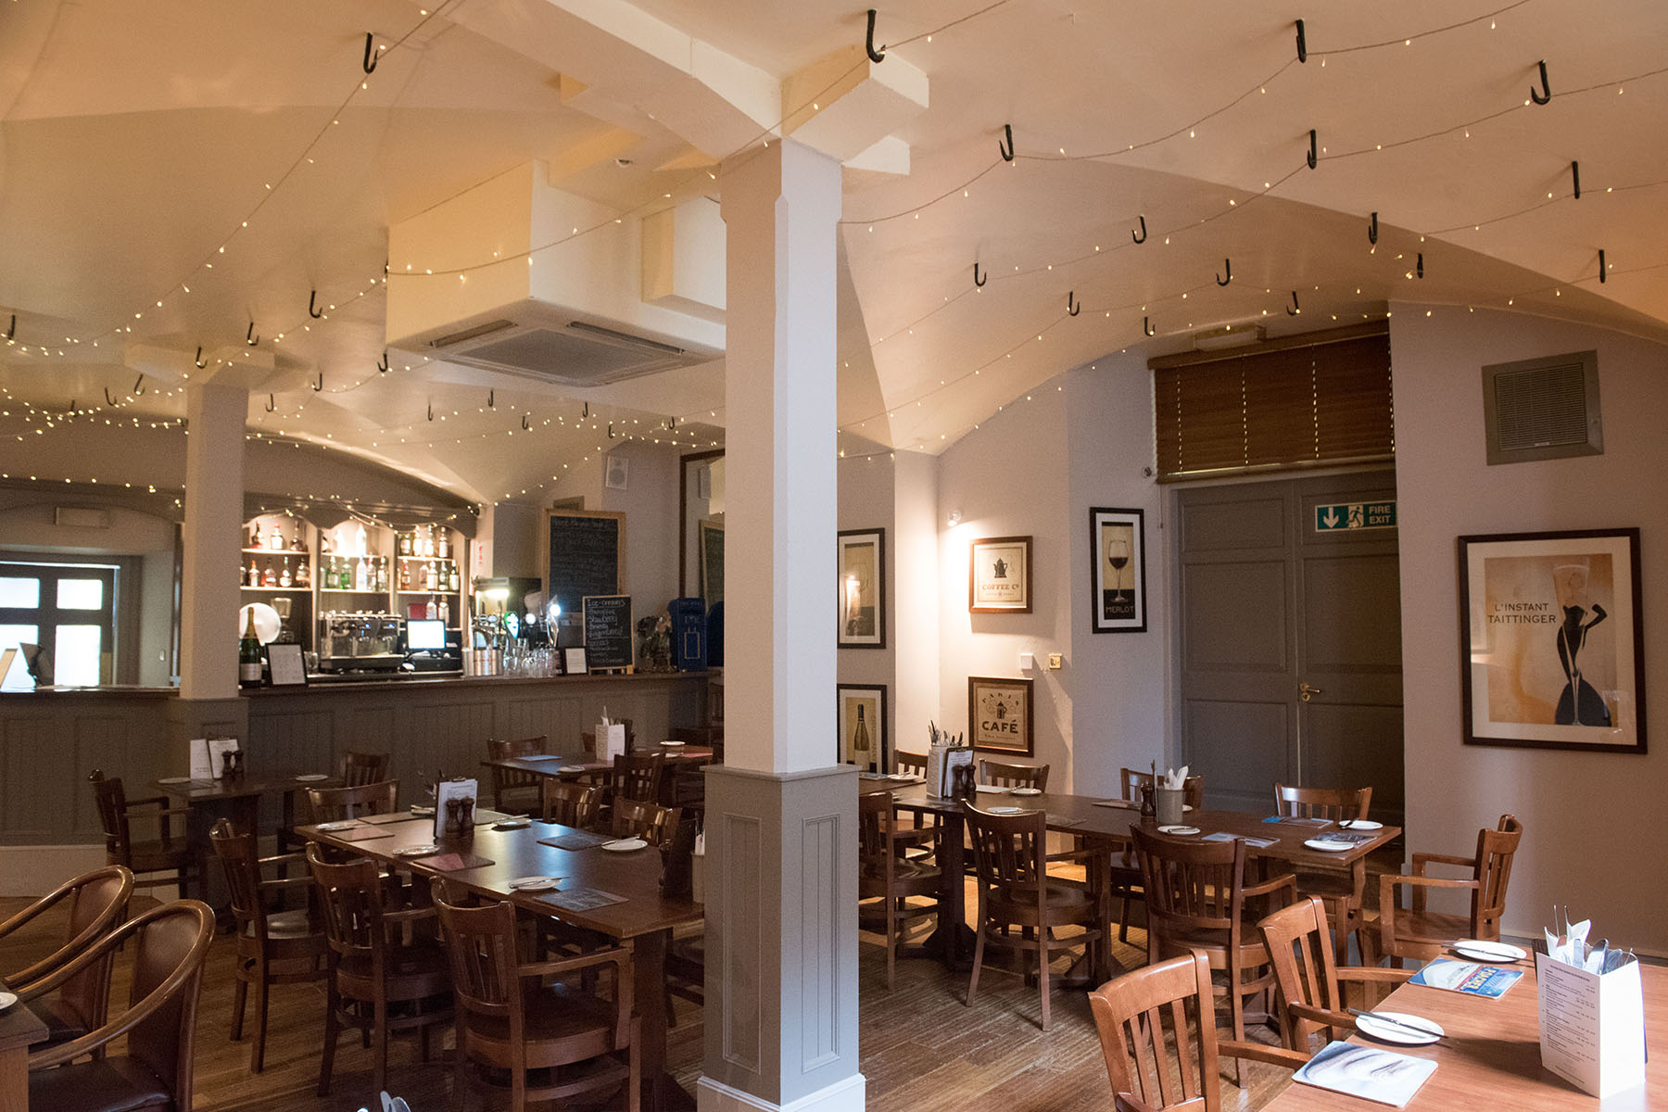

The Bistro “Pop Up Deluxe” Private Room

Our Pop-Up Bistro Deluxe Private Room is located just across from our Bistro restaurant. Drinks can be served in the private Lobby area, with the dining room itself set in candlelight and equipped with low level contemporary mood lighting, dark copper blinds, background sound dock (bring your own tunes if you so wish).

Our Pop Up Deluxe has just been re-furbished.

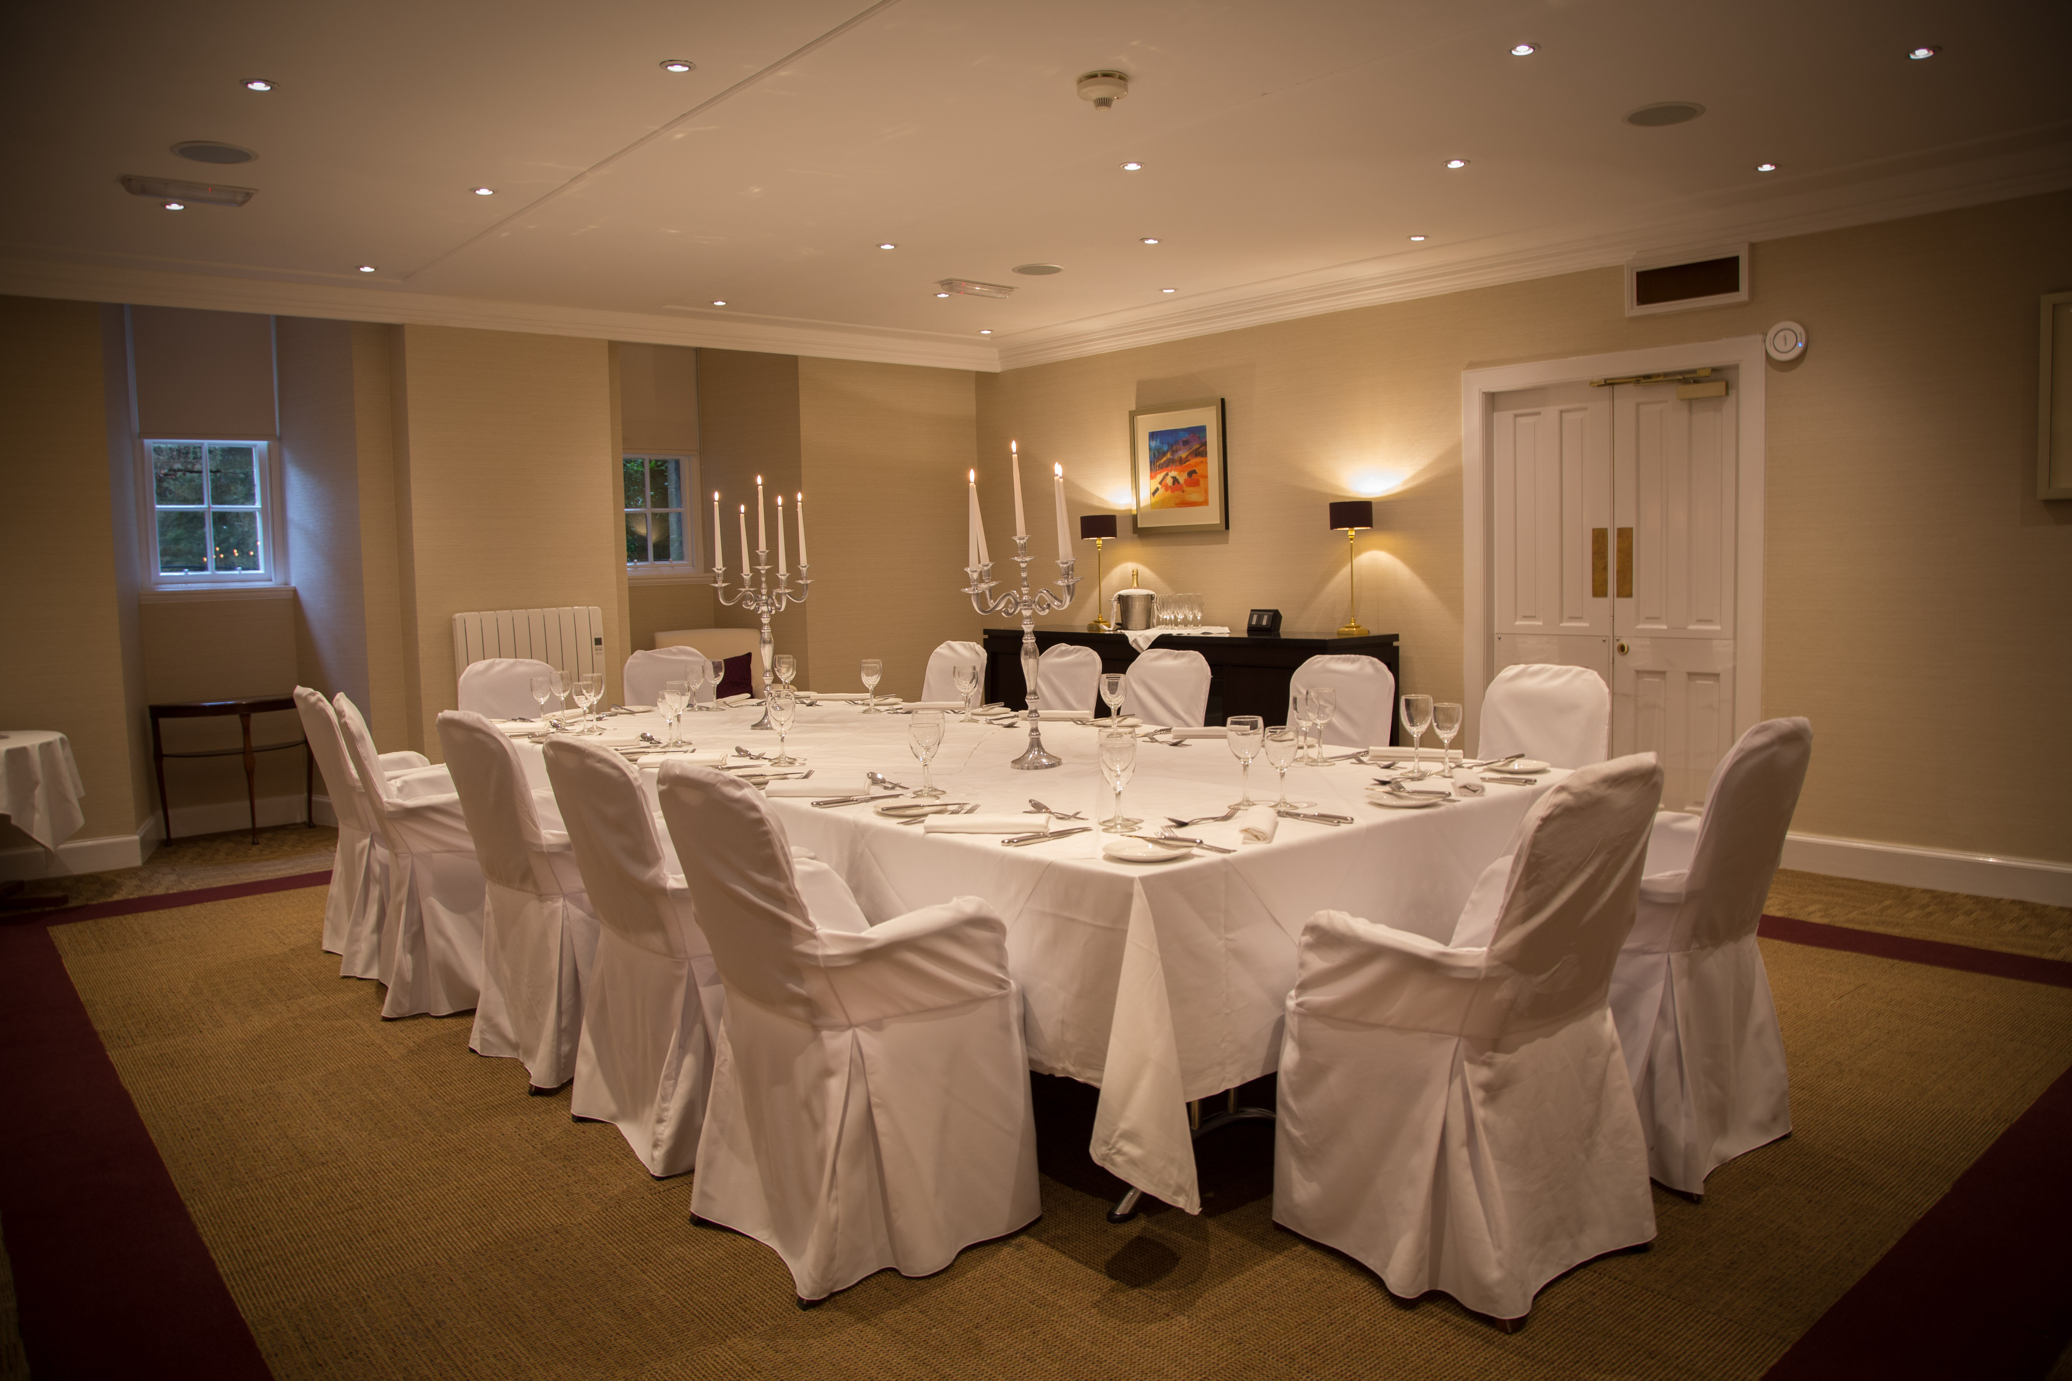

The Orangery Chef’s Table
For an experience to remember, this is a totally unique private tasting room for up to 6 covers, located directly looking into our main kitchen. Diners will be able to watch and listen to the kitchen brigade, providing a very interactive dining experience.

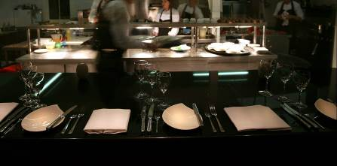

The Ballroom
The Ballroom was purpose-built in 1999. It has been designed in keeping with the old house and with Georgian arched windows around the room; flooded with natural daylight, and can seat up to 216 for lunch or dinner and up to 168 guests if space for a dance floor/band is also required. Quite magnificent!
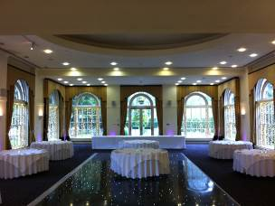
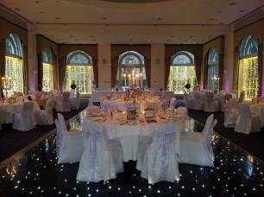

Our Private Dining and Group Dining Options at a Glance
In one word: Fabulous! A relaxed approach to wonderful and memorable celebrations, accompanied by simple yet delicious food, Balbirnie’s laid back atmosphere, however with a real sense of occasion.
Room  Name | Maximum Capacity | Maximum numbers for our different menu options
Garden Room | 18 on 1 table  20 on 2 tables | For up to 12 - full Orangery menu  For 13 and over - restricted Orangery menu (with 4 options per course)
West Room | 24 on 1 table  25-50 on round tables | For up to 12 - full Orangery menu  For 13 to 20 - restricted Orangery menu (with 4 options per course)  For 21 and over - restricted Orangery menu (with 4 options per course) but we would ask for a full pre-order  Or alternatively – one set menu
Orangery | 50-80 | For 50 and over - restricted Orangery menu (with 4 options per course) but we would ask for a full pre-order  Or alternatively – one set menu
Orangery Chef’s Table | up to 6 | Full choice from Orangery restaurant menu
Ballroom | Up to 216 | Set menu
Balbirnie Bistro  and  Bistro Private Room “Pop Up Bistro Deluxe” | Bistro  Up to 46 (available for private parties over 30 adults)  “Pop Up” Bistro  Seats 16 on 1 table/ 30 on 3 round tables | For up to 12 guests – full Bistro menu priced as taken  For 13 guests and over – restricted Bistro menu (6 options per course)-£25.00 per person, or can be priced as taken but we would ask for a full pre-order

OTHER CONSIDERATIONS FOR YOUR EVENT

We are happy to assist with recommendations for the supply floral arrangements, lighting, themed events, special stationery, and other such incidental items, all of which combine to help make your event as enjoyable and successful as possible. Billing for all external clients would be made directly to the supplier.

STATIONERY
The vast majority of Special Events at Balbirnie House involving our seasonal choice menus, simply proceed with our in-house menus.
However, should you desire unpriced and personalised menus, we can also provide these.
Please feel free to provide your own place cards and table plans, which should of course arrive earlier than the guests! If you wish, Balbirnie can provide typed table plans and typed place cards.
FLOWERS AND TABLE DECORATIONS
Please note Balbirnie does not provide flowers for private room parties. We are absolutely delighted to have the client’s own choice of florist deliver flowers for table centrepiece displays (on the day of event). You may also wish to bring along table confetti/sparkles/balloons etc. Alternatively, we can certainly recommend the services of one of our in-house florists.

Oor Fleurs www.oorfleurs.com / email: info@oorfleurs.com

Our East room fireplace has an original Stuart Park painting ‘Red and Yellow Roses in a Vase’ – hence we regularly see roses in our public areas.

FURTHER FOOD AND DRINK CONSIDERATIONS FOR PRIVATE EVENTS
LUNCH AT BALBIRNIE ADDITIONAL MENU OPTIONS
- Sorbet of the day, served as a surprise intermediate course at lunchtime £3.75 pp
- Sorbet of the day / Sherbet of the day, served as a surprise intermediate course at lunchtime, and topped with Prosecco (poured at the table) £4.50 pp
DINNER AT BALBIRNIE ADDITIONAL MENU OPTIONS
- Additional courses:
- Add Chef’s surprise pre-starter of the evening £3.75
- Add Chef’s surprise pre-dessert of the evening £3.75
- With coffee, add chocolate truffles £2.00 pp
- With coffee, add macaroons £3.00pp
LUNCH AND DINNER DRINK OPTIONS
PRE-LUNCH/DRINKS ON ARRIVAL
For any numbers up to 80 guests, we especially recommend a choice of Cocktails for drinks before lunch/dinner – a truly celebratory way to start the party!
PROSECCO ROYALE (Cassis topped with chilled Prosecco) £7.50
FRESH TWIST (House Champagne served with your choice of mint leaves, orange peel or a fresh raspberry) £8.50

House wine by the bottle £21.50 per bottle
Prosecco by the bottle £26.50 per bottle
Upgrade to Veuve Clicquot Champagne by the bottle £69.50 per bottle
Jugs of fresh orange or non-alcoholic fruit punch @ £8.50 per jug

For ease of service, we would request that groups with numbers 30 – 80 have drinks on arrival restricted to a choice of 2, plus soft drinks.
WINES WITH THE MEAL
If to be added to main account, we would ask for wines and mineral water to be pre-ordered.

AND FURTHER CONSIDERATIONS FOR GROUP LUNCH AND DINNERS IN THE BALBIRNIE BISTRO
DINING
- Nuts on the tables £1.00 pp
- Canapés of the day, 2 per guest £2.50 pp
- Sorbet of the day, served as a surprise intermediate course £3.75
- Sorbet of the day, served as a surprise intermediate course, and topped with Prosecco (poured at the table) £4.50 pp
- Coffee with tablet £3.50 pp
DRINKS
- Prosecco @ £26.50 per bottle
- Fresh Twist (House Champagne served with your choice of mint leaves, orange peel or a fresh raspberry) £8.50
- Upgrade to Veuve Clicquot by the bottle £69.50
- And of course a wide choice of spirits, wines and bottled beers

DRINKS For ease of service, we would request that groups with numbers 30 – 42 have drinks on arrival restricted to a choice of 2, plus soft drinks.
WINES WITH THE MEAL - If to be added to main account, wines and mineral water require to be pre-ordered.

THE PLEASURE IS OURS. MEMORIES ARE TRULY MADE OF THIS!

