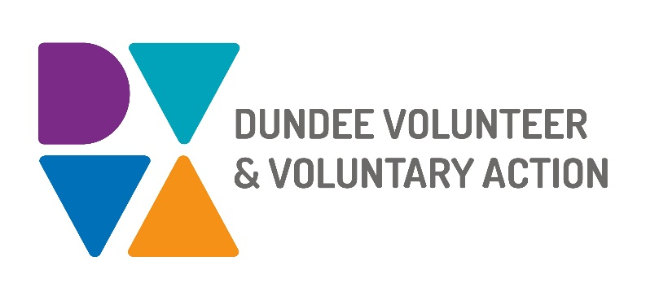
Job Description and
Person Specification

POST TITLE: Recovery Engagement Worker (Substance use)

CONTEXT
You will have lived experience of drug or alcohol recovery, either personally, or as a close friend or carer.
You will be part of a small team engaging people in recovery from problematic drug and alcohol use in community and civic life.
This is a developmental role with support and training provided. Whilst in post you will be required to:
- maintain your own recovery
- work towards a relevant vocational qualification eg SVQ in Health & Social Care or equivalent.

PURPOSE OF POST

To support the development of visible recovery groups and communities to sustain themselves and grow new responses to the challenges of community recovery in Dundee.

To support engagement and involvement of people with lived experience of substance use challenges in the planning, development, delivery, and evaluation of substance use services and supports in Dundee.

In partnership with others, to use co-production techniques and processes to maximize resource availability, and to deliver best possible health and wellbeing outcomes for all.

To contribute to developing and delivering a workplan which aligns with the mental health and substance team vision and DVVA business plan.

RESPONSIBLE TO: Recovery Network Coordinator

SALARY: Grade 3 (£21,330 - £23,700)

HOURS OF WORK: 35 hours per week, to be worked in accordance with DVVA Conditions of Service.

FUNDING: This is a fixed term post for 2 years from the start date.

ANNUAL LEAVE: 21 days per annum on appointment increasing each year by 1 day to a maximum of 25 days, plus 6 public holidays, plus 5 days Christmas closedown.

LOCATION: Initially, the post holder may be required to work from home due to Covid-19 restrictions. There may be an option for the post to be a blend of home and office working in future. Our main office is based in Dundee city centre and we have community locations in Lochee and Whitfield.

MAIN WORKING CONTACTS

- People with lived experience of substance use challenges and recovery.

- Mental Health and Substance Use Team members and other Dundee Volunteer and Voluntary Action colleagues.

- Staff, volunteers, and participants in drug and alcohol support agencies. These will include but are not limited to NHS Tayside, Dundee City Council, Dundee Health and Social Care Partnership, emergency services, national and local charities, voluntary organisations, and social enterprises.

KEY DUTIES

Engaging and involving people

- Initiate and establish healthy peer working relationships with people who have lived and living experience of substance use challenges and recovery.

- Support individuals in recovery to participate in community and civic life, appropriately and in accordance with their individual recovery goals.

- Create and maintain accurate records of all engagement and activities.

Growing Recovery Groups and Communities

- Assist in identifying existing recovery groups or communities within Dundee.

- Assist in supporting the growth and establishment of visible recovery groups across the city.

- Provide support, motivation, encouragement, and guidance to people developing recovery groups and activities.

- Assist local recovery groups or communities to deliver activities and events with and for people who are in recovery or seeking recovery support.

- Create and maintain accurate records of recovery community activity and engagement.

Growing a Lived Experience Network

- Support the establishment of a lived experience network for and with people who are or have been personally affected by substance use challenges.

- Support capacity-building so that people with lived experience can confidently participate in network activities and help shape the future of drug and alcohol recovery in Dundee.

- Keep up to date with legislation, policy, and service changes affecting local people who have substance use challenges. Share information about these and discuss with people who are in recovery.

- Assist network members and groups to respond to emerging issues and to influence matters that are important to them.

- Support and encourage individuals in recovery to reflect on their experiences and share recovery stories.

- Connect individuals in recovery with opportunities to share recovery stories, experiences, and feedback on services and supports.

Supporting lived experience involvement in decision-making

- Assist the Network Co-Ordinator to promote, advocate for, and facilitate involvement of people with lived experience of substance use challenges in decision-making relevant to drug and alcohol recovery.

- Promote opportunities for people in recovery to respond to emerging local issues and to influence matters that are important to them.
- Support and encourage people in recovery to bring their lived experiences to decision-making within Dundee’s Recovery Oriented System of Care and Drug and Alcohol Partnership.

Contributing to the development and delivery of DVVA’s Mental Health and Substance Use Engagement and Involvement Plan

- Use IT systems provided for recording, monitoring, and communication purposes.

- Maintain accurate records of attendances, outputs and outcomes to evidence work undertaken and its impacts.

- Actively and constructively participate in team meetings and activities.

- Contribute to shared team projects and developments.
- Work with others to ensure our plan and its delivery reflects the needs of individuals, organisations, and communities.

- Strive to maintain good practice in co-production.

General Duties

- Demonstrate commitment to the work of Dundee Volunteer and Voluntary Action and the Third Sector Interface. Practice and promote team and partnership working.

- Work in accordance with the organisation’s policies and procedures. Pay particular attention to those relating to lone working, risk assessment, and safe guarding.

- Identify any areas of risk and advise on improvements

- Contribute to quality assurance, which will ensure compliance with existing quality systems such as EFQM and Good Governance Award.

- Undertake personal and professional development as required by the role

OTHER DUTIES
The job description is a broad picture of the post at the date of preparation. It is not an exhaustive list of all possible duties as it is recognised that jobs change over time. Should the duties change radically then the post and grading will be reviewed.

CONDITIONS OF SERVICE
- These are set out in the organisation’s staff handbook.
- All staff meeting the qualifying criteria may join a defined contribution pension scheme provided by TPT Retirement Solutions.
- The organisation has an equal opportunities policy and seeks to be an equal opportunities employer.

TRAINING: Staff may make application to pursue appropriate training.

JOB DESCRIPTIONS are reviewed from time to time.

Revised 30/09/211

Recovery Engagement Worker (Substance Use) - Person Specification

Attribute | Essential | Desirable
Education | Must be able to read and understand key publications and reports, and to complete documentation to an acceptable standard. | Relevant qualification.
Knowledge | - Substance use issues, dependency and recovery  - Drug and alcohol services and supports  - Community based groups and activites | Recovery Oriented System of Care.  Alcohol and Drug Partnership  Community Planning
Experience | - Maintaining your personal recovery journey  - Supporting people affected by problematic substance use.  - Establishing and maintaining effective working relationships.  - Using lived experience to influence change. | Drug and Alcohol or substance services.
Skills and Abilities | - Strong interpersonal skills  - Effective team working.  - Using ICT, particularly Microsoft packages. | Outcome focused evaluation
Personal Qualities | - Highly motivated  - Team player  - Flexible  - Resilient
Additional job-related requirements | Flexible working which may include evening and occasional weekend work.  Satisfactory PVG check.
Reviewed 30th Sept 21

