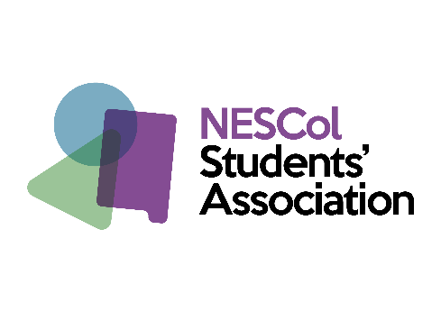
Student Association President and
Depute President Elections 2021

Dates | What happens | What this means
19 April | Notification of Elections | Timeline shared with all students
20 April to 30 April by request | Information Sessions  Email ji.reid@nescol.ac.uk and a 1:1 online sessions will be arranged to suit you | Find out more about what being a President and Depute involves. Find out how to go about applying and what you need to do to stand as a candidate.
20 April at 9 am to 30 April at 5pm | Nomination Period –This is when you can apply | Request a pack from ji.reid@nescol.ac.uk.  Then complete the form, collect nominations from fellow students and send in your manifesto.
4 May to 7 May | Candidate Briefings:  Arrangements will be made directly with candidates to suit availability | You will be advised on how to go about your campaign to encourage students to vote for you
7 May to 21 May | Campaigning period | This is when you can carry out your online campaign to encourage students to vote for you
25 May at 9am to 26 May at 5pm | Voting Period | All voting is on https://www.nescolsa.com/
27 May or as soon as possible thereafter | Results are announced at a live online session | All candidates will be asked to attend to hear the results first hand

Any Questions please email ji.reid@nescol.ac.uk

