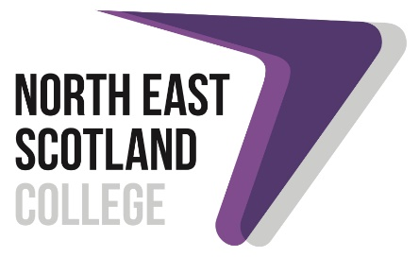

Flexible Workforce Development Fund (FWDF) 2022-23 - for SMEs
Application Form

SME eligibility information (ALL FIELDS ARE MANDATORY where applicable)
Name of employer |  |  |  |  |  |  | Company registration number (where applicable)
Number of employees |  |  |  |  |  |  | Sole proprietor/Partnership | O
 |  |  |  |  |  |  | Company | O | (please tick)
 |  |  |  |  |  |  | Non-profit making body | O
Operate across Scotland? *Please circle | YES/NO* |  |  |  |  |  | Operate across more than one college region? (Please circle) | YES/NO*
Address |  |  |  |  |  |  | Company website
Postcode |  |  |  |  |  |  | Telephone number
Contact person |  |  |  |  |  |  | Email address
Demonstrate proof of SME status |  | This should normally take the form of one of the following:  • A business bank account.  • VAT registration.  • PAYE registration.  • Companies House info (latest accounts, etc.).  • Registration for self-assessment tax return (HMRC).
Documentation used as proof of eligibility, supplemented with a signed copy

BUSINESS SKILLS GAP AND TRAINING
Does your organisation require a skills gap analysis? |  |  | O | Yes | O | No
Do you have a current skills gap analysis? |  |  | O | Yes | O | No

What needs have been identified? Including assessing priority groups such as women, disabled and black and ethnic minority employees
What training has been identified to meet the skills gap analysis?
What are the intended goals/outcomes of this training?
How many employees will benefit from the training?
What consideration have you made as an employer to support staff with protected characteristics (as listed in section 4 of the Equality Act 2010) or from other priority groups (as set out in the Fund guidance) to gain access to training through the Fund?

What is the expected impact of this training on employees/employer? Specifically, what anticipated impact will this training have on productivity?
How will this impact be evident?
Summary of final training plan and a breakdown of the training costs

Please note that by contractually agreeing to receive training through the FWDF, employer and employee details will be shared by SFC with the Scottish Government for reporting, monitoring or evaluation purposes, and may be further processed by organisations contracted to undertake this work on their behalf. Scottish Government’s privacy notice can be viewed here.
Employer declaration

- I declare that I am authorised to sign this application and that this is the only application we have made to the 2022-23 FWDF*
- I understand that all training must be contractually agreed by 31st July 2023 and have commenced by 31st August 2023 to be included as part of Colleges’ year 6 (2022-23) FWDF allocations.
- Training must conclude by 31st December 2023 unless the course is exempt i.e. SVQ; distance learning
- I understand that all training cancelled within two weeks of the agreed delivery date will be considered as delivered and no longer able to be re-scheduled. This does not include any cancellations made by the college which would be rescheduled.

Print name:

Signature: Date (DD/MM/YY):

* only one application either as a Levy-payer or a SME, and to only one training provider.

For North East Scotland College
Print name:

Signature: Date (DD/MM/YY):

