Scottish Hockey CORE Database – Team Contact Setup

- Team Contact logs in to CORE database and faces their own dashboard. To get to the club’s fixture details click on the Memberships tab

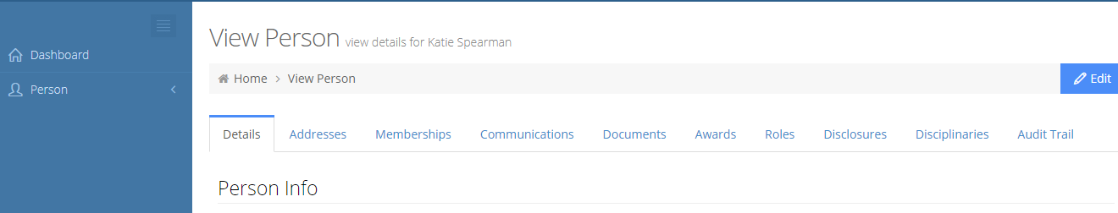

- Then click on your Club’s link as below :

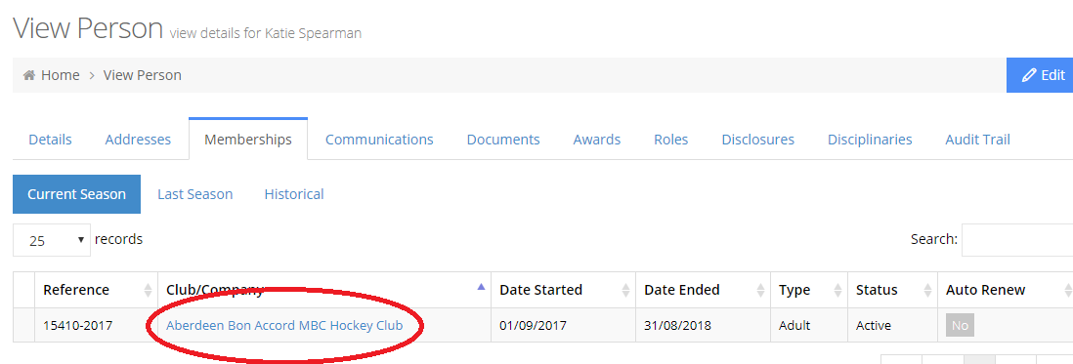

- You will then get the Club’s details, click on the Fixtures tab as below :
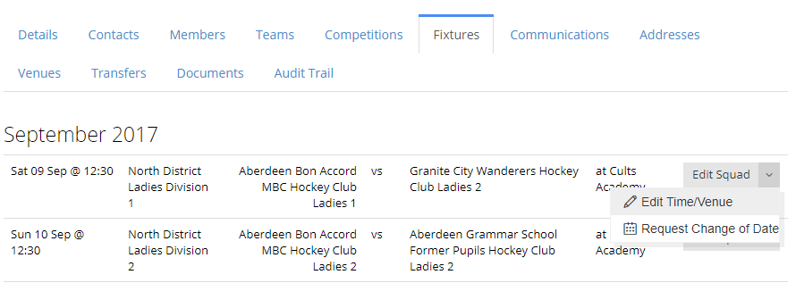

- Click on Edit Squad drop down and get the options to Edit Time/Venue and also an option to Request Change of Date, the latter will go to the Competition Administrator for approval, Time/Venue can be changed by the Team Contact.

- When a fixture has been played you will get an email to update the result, go to the same Fixtures tab as above and update the result. This will then update the League Tables.

