Scottish Hockey CORE Database – Competitions Module Setup

To enable correct communications, each club must provide a Team Contact:
- Club Admin logs in to CORE as usual

- There are new tabs showing, namely Teams, Competitions and Fixtures - go into Teams

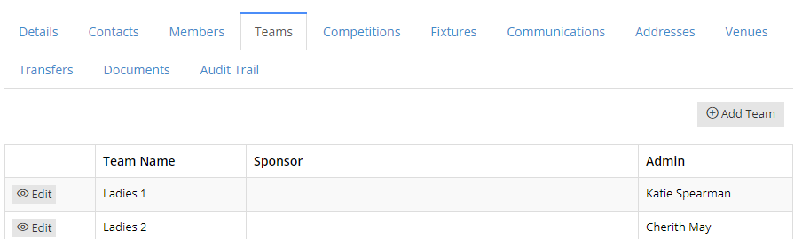

- On each team, click Edit and update the correct person in charge of team’s communication e.g Captain, Manager etc as they will receive updates for all Fixture changes done by the Competitons Administrator and emails prompting them to enter Results for each match.

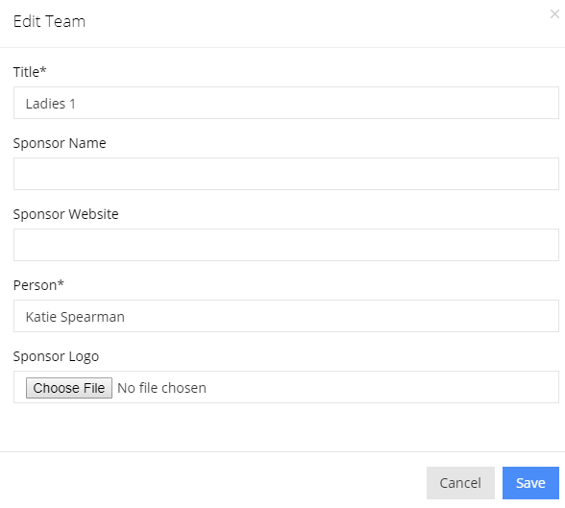
- On the Person field start typing the name of the club member and they will show, the click Save

- This must be completed before the 1st game of the season and this person must be a member of your club

- The new Team Contact will receive login details to CORE thereafter from the Service Desk at Scottish Hockey – these can be used to update the scores each week

