
SCOTTISH HOCKEY
BOARD DIRECTOR HANDBOOK
Induction and Governance Guide
Version: 2.0
Date: June 2026

Welcome to the Board of Scottish Hockey

Welcome from the Chair

Welcome to the Board of Scottish Hockey.

Thank you for choosing to volunteer your time, expertise and leadership to support hockey in Scotland. Your appointment reflects the skills, experience and perspective you bring to our organisation and to the wider hockey community.

As a Board Director, you have an important role in shaping the future of our sport. Together, the Board provides strategic leadership, ensures effective governance and financial stewardship, and creates the conditions for hockey to thrive across every community in Scotland.

This handbook has been developed to support your induction and provide an overview of how Scottish Hockey is governed, how the Board operates and what you can expect during your first few months in post.

We encourage you to ask questions, challenge constructively and contribute openly. We believe that diverse perspectives and respectful debate strengthen our decision making and help us achieve the best outcomes for hockey.

We look forward to working with you.

Neil Francis
Chair
Scottish Hockey

Contents
- About Scottish Hockey
- Our Vision, Mission and Values
- Our Strategy 2026–2031
- How Scottish Hockey is Governed
- The Role of the Board
- The Role of a Director
- Board Structure and Committees
- Board Culture and Behaviours
- Strategy, Performance and Assurance
- Finance and Risk
- Safeguarding, Integrity and Inclusion
- Cyber Security and Digital Governance
- Meetings and Decision Making
- Director Development
- Your First 90 Days
- Key Contacts
- Key Documents
- Director Checklist

1. About Scottish Hockey
Scottish Hockey is the National Governing Body for hockey in Scotland.
We exist to lead, govern and develop hockey from grassroots participation through to international performance. We work collaboratively with clubs, districts, schools, universities, volunteers, coaches, officials, players and partners to ensure hockey remains accessible, enjoyable and sustainable.
Our responsibilities include:
- Governing the sport in Scotland
- Developing participation opportunities
- Supporting affiliated clubs
- Organising national competitions
- Developing coaches, officials and volunteers
- Delivering talent pathways
- Supporting Scottish national teams
- Safeguarding participants
- Promoting equality, diversity and inclusion
- Managing relationships with national and international partners
Scottish Hockey is committed to creating positive experiences and opportunities for everyone involved in our sport.

2. Our Vision, Mission and Values
Vision
Hockey is a game for everyone and a sport for life.

Mission
To work together as a hockey family to shape the future of the sport and create experiences that last a lifetime.
.
Our Values
Community

Integrity

Inclusion

Consciously Sustainable

3. Our Strategy 2026–2031
The Board is responsible for delivering Scottish Hockey's strategic ambition.
Our strategy provides a clear framework for the next five years and has been developed in partnership with the hockey community.

The strategy focuses on four priorities:
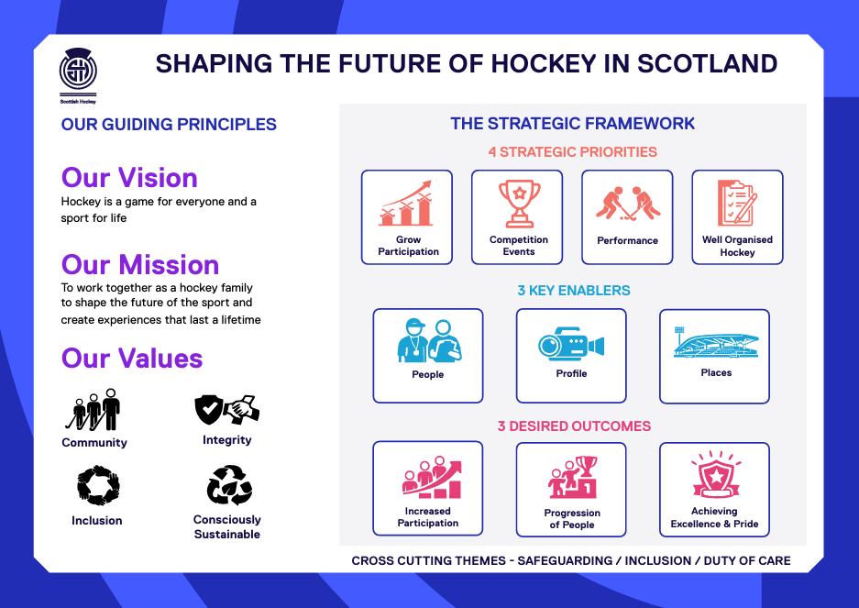

The Board monitors progress against strategic objectives through agreed performance measures, regular reporting and annual business planning.

4. How Scottish Hockey is Governed
Scottish Hockey is governed through a framework that ensures accountability, transparency and effective decision making.

The governance framework includes:
- Articles of Association
- Board Terms of Reference
- Sub Committee Terms of Reference
- Scheme of Delegation
- Board Code of Conduct
- Financial Procedures
- Risk Management Framework
- Strategic Plan
- Annual Business Plan
- Key organisational policies
The Board delegates responsibility for operational delivery to the Chief Executive while retaining responsibility for governance, strategy and organisational performance.

5. The Role of the Board
The Board provides strategic leadership and oversight.
Its principal responsibilities include:
- Setting strategic direction
- Approving organisational priorities
- Monitoring organisational performance
- Approving annual budgets
- Ensuring financial sustainability
- Managing strategic risk
- Ensuring legal and regulatory compliance
- Appointing and supporting the Chief Executive
- Monitoring organisational culture
- Protecting Scottish Hockey's reputation
- Acting in the best interests of members and the sport

The Board operates collectively.
Individual Directors do not have authority to make decisions on behalf of Scottish Hockey unless specifically delegated by the Board.

6. The Role of a Director
As a Director you are a non executive company director.
You have collective responsibility for every Board decision.
Directors are expected to:
- Prepare thoroughly for meetings
- Read Board papers in advance
- Attend meetings regularly
- Participate constructively
- Ask appropriate questions
- Exercise independent judgement
- Support agreed Board decisions
- Maintain confidentiality
- Declare conflicts of interest
- Act at all times in Scottish Hockey's best interests
Legal Duties
Directors must:
- Act within their powers.
- Promote the success of Scottish Hockey.
- Exercise independent judgement.
- Exercise reasonable care, skill and diligence.
- Avoid conflicts of interest.
- Declare interests.
- Not accept benefits from third parties.
- Ensure appropriate financial stewardship.
Directors should familiarise themselves with relevant company legislation and understand their responsibilities as office holders. For further information please contact the Senior Finance Officer

7. Board Structure
The Board currently comprises:
- Chair
- Independent Directors
- Elected Directors
- Chief Executive

The Board is supported by committees.
Finance, Risk and Audit Committee
Provides assurance regarding:
- Financial reporting
- Internal controls
- Audit
- Risk management
- Financial sustainability
Renumerations, Nominations and People Committee
Provides oversight of:
- Organisational culture
- Performance
- Remuneration
- Workforce planning
- Succession planning
- Governance relating to people

Safeguarding Committee and Performance Committee

Districts Committee
Supports engagement with districts and member clubs while providing advice on community hockey development and participation.

Committees provide assurance and recommendations to the Board.
The Board retains responsibility for all decisions.

8. Board Culture and Behaviours
Scottish Hockey is committed to effective governance built upon trust, respect and accountability.

Directors are expected to:
- Listen actively.
- Challenge constructively.
- Encourage different perspectives.
- Respect confidential information.
- Focus on strategic matters.
- Support collective decisions.
- Act with integrity.
- Demonstrate the organisation's values.

Healthy debate is encouraged.
Once decisions have been made, Directors are expected to support them collectively.

9. Strategy, Performance and Assurance
The Board monitors organisational performance through:
- Strategic KPIs
- Business Plan reporting
- Financial reports
- Risk reports
- Committee assurance reports
- CEO reports
- Safeguarding reports
- Equality monitoring
- Performance programme updates
Performance reporting enables the Board to assess whether Scottish Hockey is delivering against its strategic objectives.

10. Finance and Risk
Every Director shares responsibility for financial stewardship.
The Board approves:
- Annual budget
- Financial strategy
- Reserves policy
- Major expenditure
- Annual accounts

The Finance, Risk and Audit Committee provides assurance on financial management and internal controls.

Risk Management
Scottish Hockey maintains a strategic Risk Register.
The Board reviews key risks including:
- Financial sustainability
- Safeguarding
- Reputation
- Cyber security
- Governance
- Participation
- High-performance delivery
- Workforce capacity

The Board regularly reviews whether risks remain within its agreed risk appetite.

11. Safeguarding, Integrity and Inclusion
The safety and wellbeing of participants is fundamental.
The Board receives assurance regarding safeguarding arrangements and promotes a culture where concerns can be raised openly.

Directors are expected to understand:
- Safeguarding responsibilities
- Child protection arrangements
- Adult protection responsibilities
- Reporting procedures
- Equality, Diversity and Inclusion
- Anti-discrimination
- Respectful behaviours

The Board also oversees organisational integrity including:
- Complaints
- Whistleblowing
- Ethical conduct
- Anti-doping awareness
- Disciplinary frameworks

12. Cyber Security and Digital Governance
Digital governance is an important responsibility of modern Boards.
Directors should understand:
- Cyber security risks
- Data protection obligations
- GDPR responsibilities
- Information governance
- Secure use of Board papers
- Password security
- Incident reporting

Artificial Intelligence
Scottish Hockey recognises that Artificial Intelligence presents opportunities and risks.
The Board supports responsible use of AI that:
- Protects confidential information
- Supports better decision making
- Maintains transparency
- Respects copyright
- Complies with relevant legislation

Directors should avoid uploading confidential Board information into publicly available AI systems unless authorised under organisational policy.

13. Meetings and Decision Making
The Board normally meets quarterly each year together with strategic planning sessions and the Annual General Meeting.
Directors should:
- Read papers beforehand.
- Notify apologies in advance.
- Declare conflicts.
- Participate fully.
- Respect confidentiality.
Board decisions are normally reached by consensus.
Where required, decisions may be determined by formal vote.

14. Director Development
Scottish Hockey is committed to continuous improvement.
New Directors are encouraged to complete:
- Governance induction booklet
- Safeguarding training for board members and/ or CWPS/ CWPO
- Equality, Diversity and Inclusion training
- Finance briefing
- Risk management briefing
- Cyber security awareness
- Board effectiveness development
Directors are encouraged to participate in external governance training and undertake ongoing professional development.

15. Your First 90 Days
Month One
- Meet the Chair.
- Meet the Chief Executive.
- Complete induction.
- Read key governance documents.
- Submit Register of Interests.
- Attend first Board meeting.
- Complete declaration of good character and PVG
Month Two
- Meet Executive Team members.
- Attend Sub Committee meeting.
- Visit a club or competition.
- Review current strategic priorities.
Month Three
- Complete mandatory training (Safeguarding training for board or CWPS.
- Meet with Chair for induction review.
- Identify personal development objectives.

16. Key Contacts
Chair – Neil Francis
Strategic leadership and Board governance.
Chief Executive Officer – Derek Keir
Operational leadership and organisational delivery.
Executive Lead Manager Leadership Team
- Performance – Vikki Strachan
- Participation – Nicola Wilson
- Business Operations – Rob Moffat

17. Key Documents
New Directors will receive access to each of the following in prepreation for board meetings or on the website:
- Articles of Association
- Strategic Plan
- Annual Business Plan
- Board Calendar
- Board Terms of Reference
- Committee Terms of Reference
- Risk Register
- Latest Annual Report
- Audited Accounts
- Current Budget
- Board Code of Conduct
- Register of Interests
- Conflict of Interest Policy
- Safeguarding Policy
- Equality, Diversity and Inclusion Policy
- Whistleblowing Policy
- Complaints Policy
- Data Protection Policy
- Cyber Security Policy
- Expenses Policy

18. Director Induction Checklist
Within your first three months please ensure you have:
☐ Met the Chair
☐ Met the Chief Executive
☐ Completed induction
☐ Reviewed the Strategic Plan
☐ Read the Articles of Association
☐ Read the Board Code of Conduct
☐ Signed Register of Interests
☐ Completed mandatory safeguarding training for board directors
☐ Read the Equality, Diversity and Inclusion policy
☐ Attended your first Board meeting
☐ Joined your allocated Sub Committee
☐ Visited a club, competition or performance programme
☐ Met members of the Executive Leadership Team
☐ Agreed your personal development objectives with the Chair

Thank You

Thank you for joining the Board of Scottish Hockey.

Your leadership, expertise and commitment will help shape the future of hockey in Scotland. By working together with our clubs, volunteers, players, officials and partners, we will continue to build strong foundations for the sport to grow, succeed and inspire future generations.

We look forward to working with you and wish you every success in your role as a Board Director.

Derek Keir
CEO

Staffing Structure as at 27.6.26

